**MID TERM 2 2024**

**BIOLOGY FORM TWO EXAMS**

Name...............................................................Adm number.............................

Candidates Signature......................................Date...........................................

**Instructions to Candidate**

(a)Write your name and class in the spaces provided above.

(b)Sign and write the date of examination in the spaces provided above.

(c)Answer all the questions in this paper.

(d)All answers should be written in the space provided in the question.

(e)This paper consists of **28 QUESTIONS** and 10 printed pages.

(f)Candidates should check the question paper to ascertain that all the pages are printed as indicated and no questions are missing.

**For Examiners Use Only**

|  |  |
| --- | --- |
| Number | Marks |
| 1-28 | 80 |

1. State the importance of each of the following in living organisms?

(a)Gaseous exchange (1 mark)

.........................................................................................................................................

.........................................................................................................................................(b)Excretion. (1 mark)

.........................................................................................................................................

........................................................................................................................................2. (a)Name the form in which each of the following respiratory gases are transported by the blood (2mks)

Oxygen gas.......................................................................................................................

Carbon (IV) oxide………………………………………………………………………………………..

(b) State two adaptations of red blood cells it its functions (2mks)

.........................................................................................................................................

..........................................................................................................................................

3. Students set up an experiment as illustrated below.

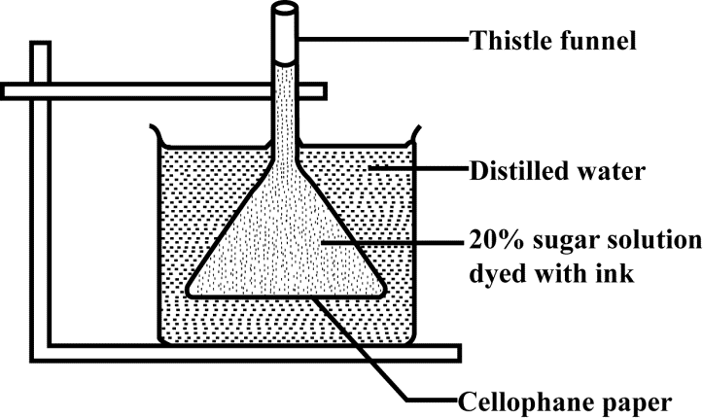

(a)Name the physiological process that resulted in the observations made after 30 minutes. (1 mark)

.....................................................................................................................................

(b)State the importance of the physiological process investigated in plants. (1 mark)

......................................................................................................................................

(c)Account the observations made after 30 minutes. (2 marks)

......................................................................................................................................

......................................................................................................................................

4. State two roles of coverslip when preparing a specimen for observation

under a light microscope. (2 marks)

......................................................................................................................................

.....................................................................................................................................

5. State two functions of Golgi apparatus. (2marks)

........................................................................................................................................

........................................................................................................................................

6. The diagram below shows an apparatus used for biological investigations



1. Name the apparatus (1 mark)

……………………………………………………………………………………….…………..

1. State its use (1 mark)

……………………………………………………………………………………………………………………………………………………………………………………………………… ……… 7. Explain how the human nostril is adapted to gaseous exchange. (2marks)

.........................................................................................................................................

.........................................................................................................................................

.........................................................................................................................................

8. The diagram below represents an experimental set up to investigate a certain scientific concept. The potted plant was first destarched by keeping it in dark for four days.

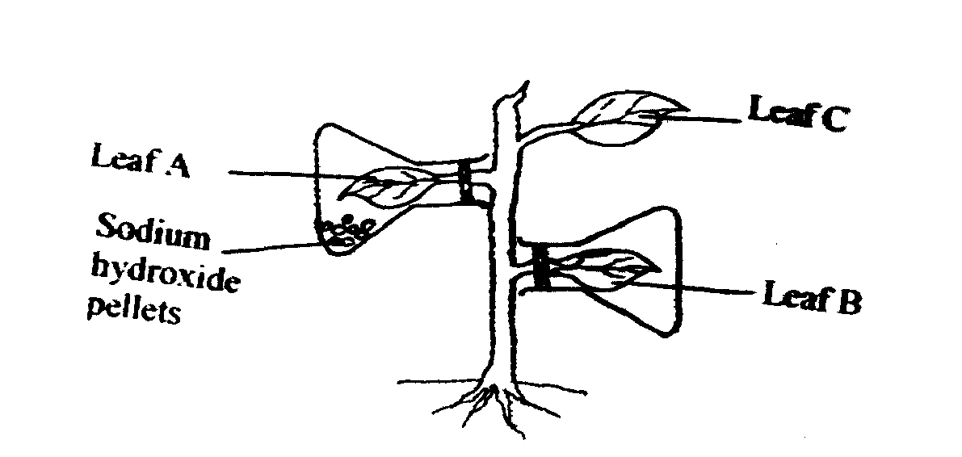

The set up was then placed in sunlight for five hours and leaves were tested for starch

(a) Name the process that was being investigated (1mark)

………………………………………………………………………………………………………………..

(b) (i) Give the results likely to be obtained after starch test for A and B

A……………………………………………………………………………….. (1mark)

B…………………………………………………………………………………. (1mark)

(ii) State the function of sodium hydroxide pellets in the above experiment

…………………………………………………………………………………………………………….

9. Explain two adaptations of small intestine to its function. (2marks)

..................................................................................................................................................................................................................................................................................

10. State two rule of Binomial nomenclature (2mks)

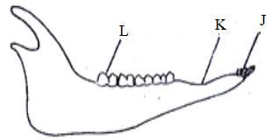…………………………………………………………………………………………………………………………………………………………………………………………………………………………………… 11. The diagram below represents the lower jaw of a mammal.

(a) Name the mode of nutrition of the mammal whose jaw is shown. (1mark)

........................................................................................................................................

(ii) Give a reason for your answer in a) above. (1mark)

........................................................................................................................................

(iii) Name and give the function of the toothless gap labeled K. (2marks)

Name...............................................................................................................................

Function..........................................................................................................................

(iv) State one structural and one functional difference between the teeth labelled J and L.

(2marks)

|  |  |  |
| --- | --- | --- |
| Teeth | J | L |
| Structural |  |  |
| Functional |  |  |

12. The diagram below illustrates tissue fluid and cells surrounding a capillary.

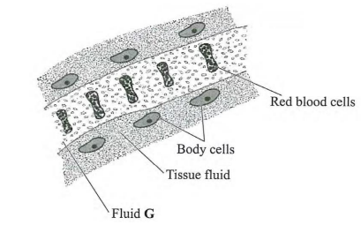

(i) Give two ways by which fluid G is different from tissue fluid. (2marks)

........................................................................................................................................................................................................................................................................................................................................................................................................................

(ii) Explain the difference between blood plasma and serum. (2marks)

................................................................................................................................................................................................................................................................................

13. Name two disease of the heart

…………………………………………………………………………………………………………………………………………………………………………………………………………………………………..

14. State the functions of the following in the heart

(i) Pericardium membrane. (1mark)

..........................................................................................................................................................................................................................................................................................................

(ii) Vagus nerve. (1mark)

.....................................................................................................................................................

(iii) Septum (1mark)

.....................................................................................................................................................

15. The diagram below shows a gaseous exchange system in a locust.

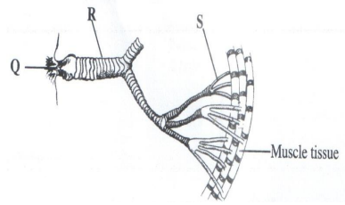

1. Use the diagram to answer the questions that follows;

Name the parts labelled R and Q (2mks)

R.....................................................................................................................................Q.....................................................................................................................................

(ii). State two adaptations of part R to its functions (2mks)

........................................................................................................................................................................................................................................................................................................................................................................................................................

16.Explain why the left ventricle of the of mammalian heart has thicker walls compared the right ventricles. (2mks)

……………………………………………………………………………………………………………………………………………………………………………………………………………………………………

17.State two functions of cuticle that covers the surface of a leaf (2mks)

…………………………………………………………………………………………………………………………………………………………………………………………………………………………………..

18. The apparatus below is used to measure a certain process in plants.Use it to answer questions that follows

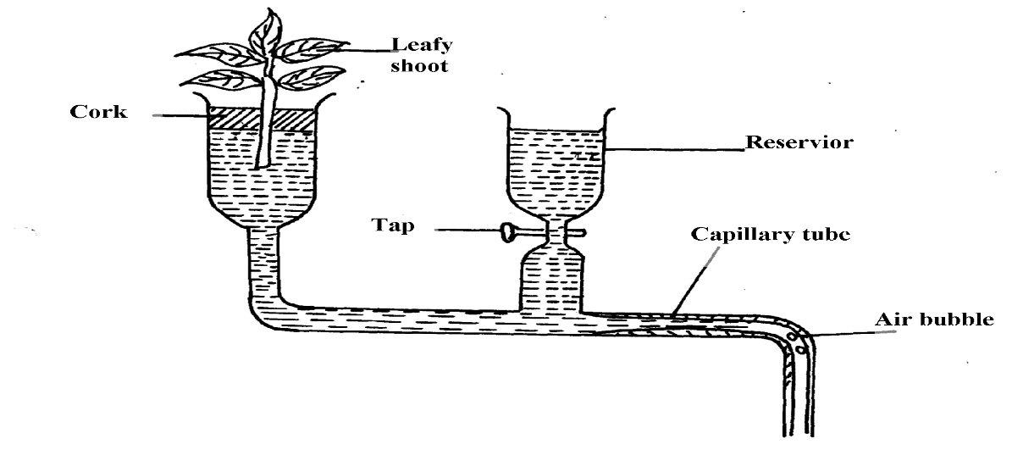

1. Name the apparatus (1mk)

…………………………………………………………………………………………………………………

1. State the process under investigation (1mk)

………………………………………………………………………………………………………………….

1. State two precautions to be observed when using the apparatus above (2mks)

…………………………………………………………………………………………………………………………………………………………………………………………………………………………………….

19. The graph below illustrates the effect of pH on certain **protein-digesting** enzymes,

S and T

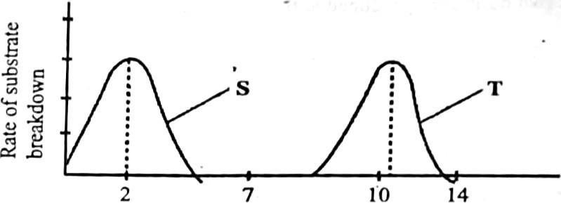

PH Value

(a)Name enzyme S and T. (2marks)

S........................................................................T............................................................

(b) Name the part of the alimentary canal where enzyme T is likely to be found- (1 mark)

20. State two site for gaseous exchange in terrestrial plants (2mks)

……………………………………………………………………………………………………………………………………………………………………………………………………………………………………

. T 21. The diagram below indicates parts of a microscope use it to answer the questions that follows

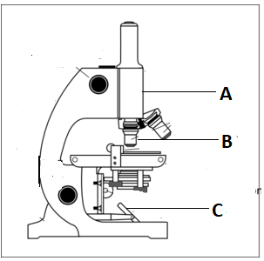

(a)

(i)

Name the parts labelled

A…………………………………………………………………………………………………….(1mark)

(ii) B………………………………………………………………………………………………………...(1mark)

(b C. What is the function of the part labelled C in the above diagram (1mark)

………………………………………………………………………………………………………………..

22. The following is an illustration of a certain process that occurs in mammals

+ Juice **X** process **P**

a fat molecule

(a) Name process **P**………………………………………………………… (1mark)

(b) Name the juice involved in the process P………………………… (1 mark)

23.The diagram below represents a structure found in plants.



(a) Name the parts labelled P and R (2 mks)

P ...................................................................

R ...................................................................

(b) State two adaptations of part Q to its functions (2 mks)

...........................................................................................................................................................................................................................................................................................................

………………………………………………………………………………………………….

24.Name the bacteria the causes the following respiratory diseases (2mks)

(i) Whooping cough ………………………………………………………………………………………………

(ii) Pneumonia………………………………………………………………………………….

25. Give the reason for carrying out the following procedures during temporary slide preparation (3mks)

(i) Cutting into thin sections………………………………………………………………………………………..

(ii) Addition of iodine solution………………………………………………………………………………….

(iii)Cutting the section using a sharp razor…………………………………………………………………………………………………………………………….

1. The following is a schematic representation of the blood clotting process.

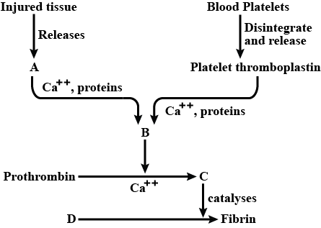

1. Identify the following components of the blood clotting process. (2 marks)

i) **C** ……………………………………………………………………………………...

ii) **D** ……………………………………………………………………………………..

1. i) Name the component of blood that stops the process illustrated above. (1 mark)

…………………………………………………………………………………………

ii) Name the vitamin that is required for the above process (1mk) ………………………………………………………………………………………………

27.State two roles of lipids in the body (2mks)

…………………………………………………………………………………………………………………………………………………………………………………………………………………….

28. Below is the basic functional unit of an organism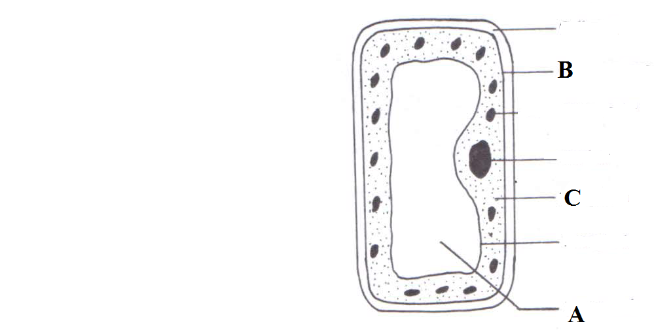

State the functions of the parts labeled:

(i) A………………………….…………………………………………………………. (1 mark)

(ii) B………………………….………………………………………………………… (1 mark)

(iii) C……………………………….…………………………………………………… (1 mark)