**FORM THREE CHEMISTRY-NOV-DEC HOLIDAY-DAILY DOSES-2024**

**1**.a) A student reacted concentrated sulphuric VI acid with sulphur.Write an equation for the reaction.

b) Which property of sulphur is demonstrated above?

**2**.State & explain the observations made when burning magnesium was plunged into a gas jar containing sulphur IV oxide.

**3**.a) Explain why a solution of hydrogen chloride in methyl benzene does not turn blue litmus paper red.

b)(i) A solution of hydrochloric acid was added to sodium hydrogen carbonate.State the observation made.

(ii) Write an ionic equation for the reaction.

4.(i) State;

a) Boyle͗ s law.

b) Charles law.

c) Grahams law of diffusion.

d) Gay lussacs law.

(ii) Sketch graphs to demonstrate:

a) Boyle͗ s law.

b) Charles law.

**5.**Gas X diffuses through a porous material at a rate of 14cm3/s whereas a Y diffuses through the same material at a rate of 9.5cm3/s.Given that the molar mass of X is 16,calculate the molar mass of Y.

6.400cm3 of oxygen diffuse through a porous plate in 50 seconds.How long will it take 400cm3 of sulphur (IV) oxide to diffuse through the same plate under same conditions?(O=16,S=32)

7.A given volume of ozone (03) ,diffused from a certain apparatus in 96 seconds.Determine the time taken by an equal volume of carbon (IV) oxide to diffuse under the same conditions.(O=16,C=12)

8.A gas occupies 700cm3 at 17oC and pressure of 740mmHg.What volume would it occupy at s.t.p?

9.A certain gas has a volume of 214cm3 at a temperature of -27 oC and pressure of 710mmHg.Determine its pressure if it occupies a volume of 315cm3 and 17oC .

10.A certain volume of nitrogen gas diffused through a porous pot in 80 seconds.Under same conditions,the same volume of unknown gas Y diffused in 85.52 seconds.Determine the molecular mass of the unknown gas Y.(N=14)

11.88cm3 of gas K diffused through a small hole in 40 seconds while 50cm3 of hydrogen gas diffused through the same hole under the same conditions in 5 seconds.Determine the RMM of gas K.(H=1)

1. **ALKANE**

**12**.Give the structural formula of the following alkanes.

(a) 2-methylhexane.

(b) 2,2-dimethylpropane.

(c) 2,3,3-trichloropentane.

(d) 3,4-diethylhexane.

(e) 2,3,3-trimethylpentane.

**13**.Draw and name ALL isomers of pentane.

**14**.Draw and name ALL isomers of hexane.

**15**.Distinguish between;

(a) Saturated and unsaturated hydrocarbons.

(b) Catalytic and thermal cracking.

**16**.State any **three** uses of alkanes.

**17**.(a) Name the **reagents** one can use to prepare ethane gas in the laboratory.

(b) Write an equation for the reaction that occurs in preparation of ethane gas.

(c ) Draw a set-up of the apparatus that can be used to prepare ethane in the lab.

**18**.(a) Name the **reagents** one can use to prepare methane gas in the laboratory.

(b) Write an equation for the reaction that occurs in preparation of methane gas.

**ALKENE**

19.Give the structural formula of the following alkenes.

(a) 2-methylbut-2-ene.

(b) 2,3-dimethylpent-2-ene.

(c ) hex-2-ene.

(d) 3-chlro-2-methylbut-2-ene.

(e) 2,3,3-trimethylbut-1-ene.

**20**.Draw and name **two** isomers of butene.

21.Draw and name **two** isomers of pentene.

22.State **three** uses of alkenes.

23.Write chemical equations to show the complete combustion of:

(i) Ethene.

(ii) Butene.

(iii) Propene.

(iv) Penten.

(v) Hexene.

24.Ethene is prepared in the laboratory by dehydration of ethanol.

(a) Name a suitable dehydrating agent used in this process.

(b) State the condition necessary for the reaction to occur.

25.Write the chemical equations and name the products for the following equations.

(a) Reaction between ethene with;

(i) 1 mole of bromine.

(ii) 1 mole of hydrogen chloride,

(iii) 1 mole of hydrogen.

(b) Reaction between propene with;

(i) 1 mole of bromine.

(ii) 1 mole of hydrogen chloride,

(iii) 1 mole of hydrogen.

**ALKYNE**

**26**.Give the structural formula of the following compounds.

(a) 4-methylpenty-2-yne.

(b) ethyne.

(c ) 3-chloro-3-methylbut-1-yne.

(d) 4-methylhex-2-yne.

(e) 3-methylbut-1-yne.

**27**.Draw and name isomers of butyne.

**28**.Draw and name isomers of hexyne.

**29**.Write equations to show complete combustion of;

(i) Ethyne.

(ii) Butyne.

(iii) Propyne.

(iv) Pentyne.

(v) Hexyne.

**30**.(a)Name **two** reagents used to prepare ethyne gas in the laboratory.

(b) Write the chemical equation for the reaction between the reagents named in (a) above.

**31**.Write the chemical equations and name the products for the following equations.

(a) Reaction between ethyne with;

(i) 1 mole of bromine.

(ii) 1 mole of hydrogen chloride,

(iii) 1 mole of hydrogen.

(iv) 2 moles of bromine.

(v) 2 moles of hydrogen chloride,

(vi) 2 moles of hydrogen.

(b) Reaction between propyne with;

(i) 1 mole of bromine.

(ii) 1 mole of hydrogen chloride,

(iii) 1 mole of hydrogen.

(iv) 2 moles of bromine.

(v) 2 moles of hydrogen chloride,

**32**.(a) The table below shows the tests that were carried out on 3 portions of a compound and the results obtained.Study it & answer the questions that follow.

|  |  |  |
| --- | --- | --- |
|  | Test | Observations |
| 1 | Addition of few drops of ammonium hydroxide to the 1st portion until in excess. | White precipitate soluble in excess. |
| 2 | Addition of few drops of acidified barium nitrate to the 2nd portion. | White precipitate formed. |
| 3 | Addition of few drops of lead II nitrate to the 3rd portion. | White precipitate formed. |

(i)Identify the cations and anions present in the compound.

1. Write an ionic equation for the reaction in the 3rd portion.

(b ) Consider the flow chart below,use it to answer the questions that follow.

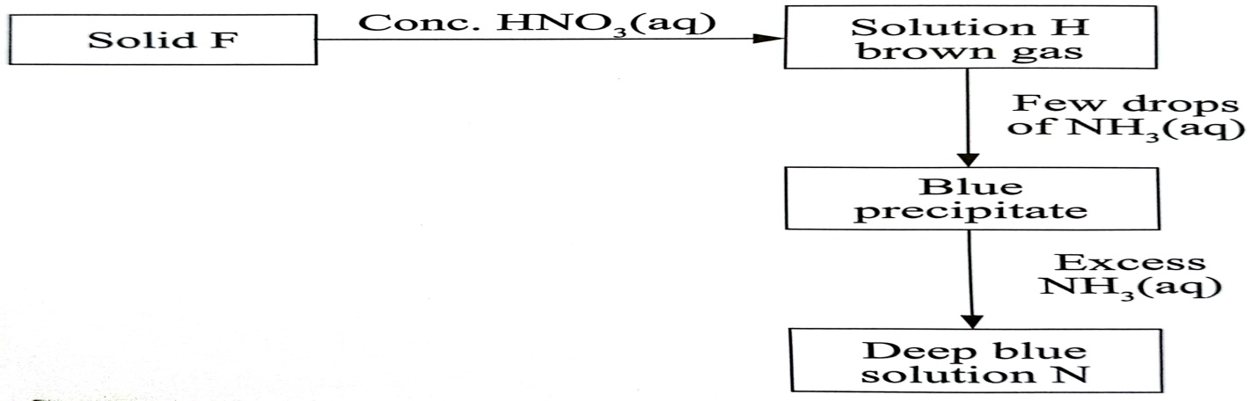

1. State the most likely identity of solid F.
2. Write the chemical equation for the reaction between solid F and concentrated nitric V acid.
3. Name solution N.

**33**.Study the flow chart and answer the questions that follow.

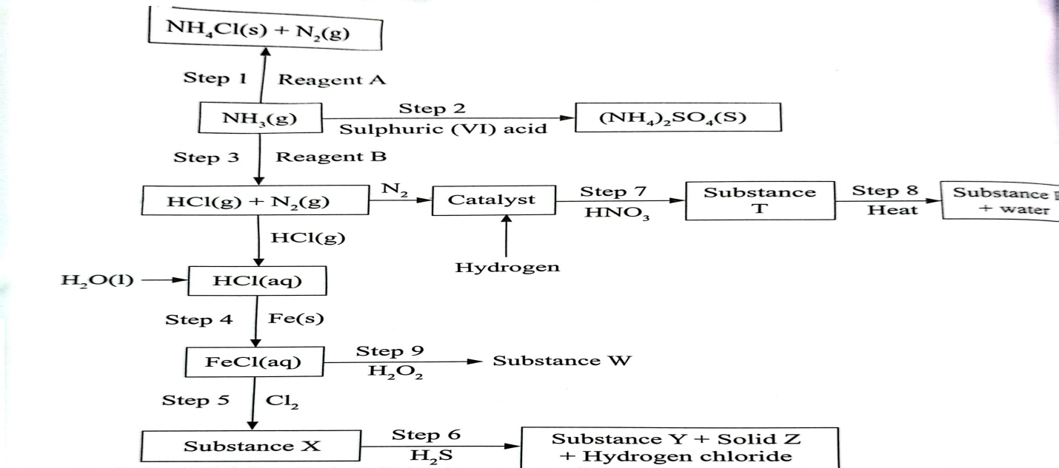

1. (i) Reagent A. (ii) Reagent B (iii) Substance T. (iv) Substance R.
2. Write an equation for the reactions in
3. Step 6
4. Step 8

(c ) State the observations made in step 5.Explain.

(d ) State the observations made in step 6.Explain.

(e ) State the observations made in step 9.Explain.

(f) State one use of:

(i) Solid Z.

(ii) Ammonium sulphate.

**34**.The set up below shows the reagents that can form hydrogen gas in a laboratory.

(a) Complete the diagram to show how a dry sample of hydrogen gas can be collected. (3 marks)

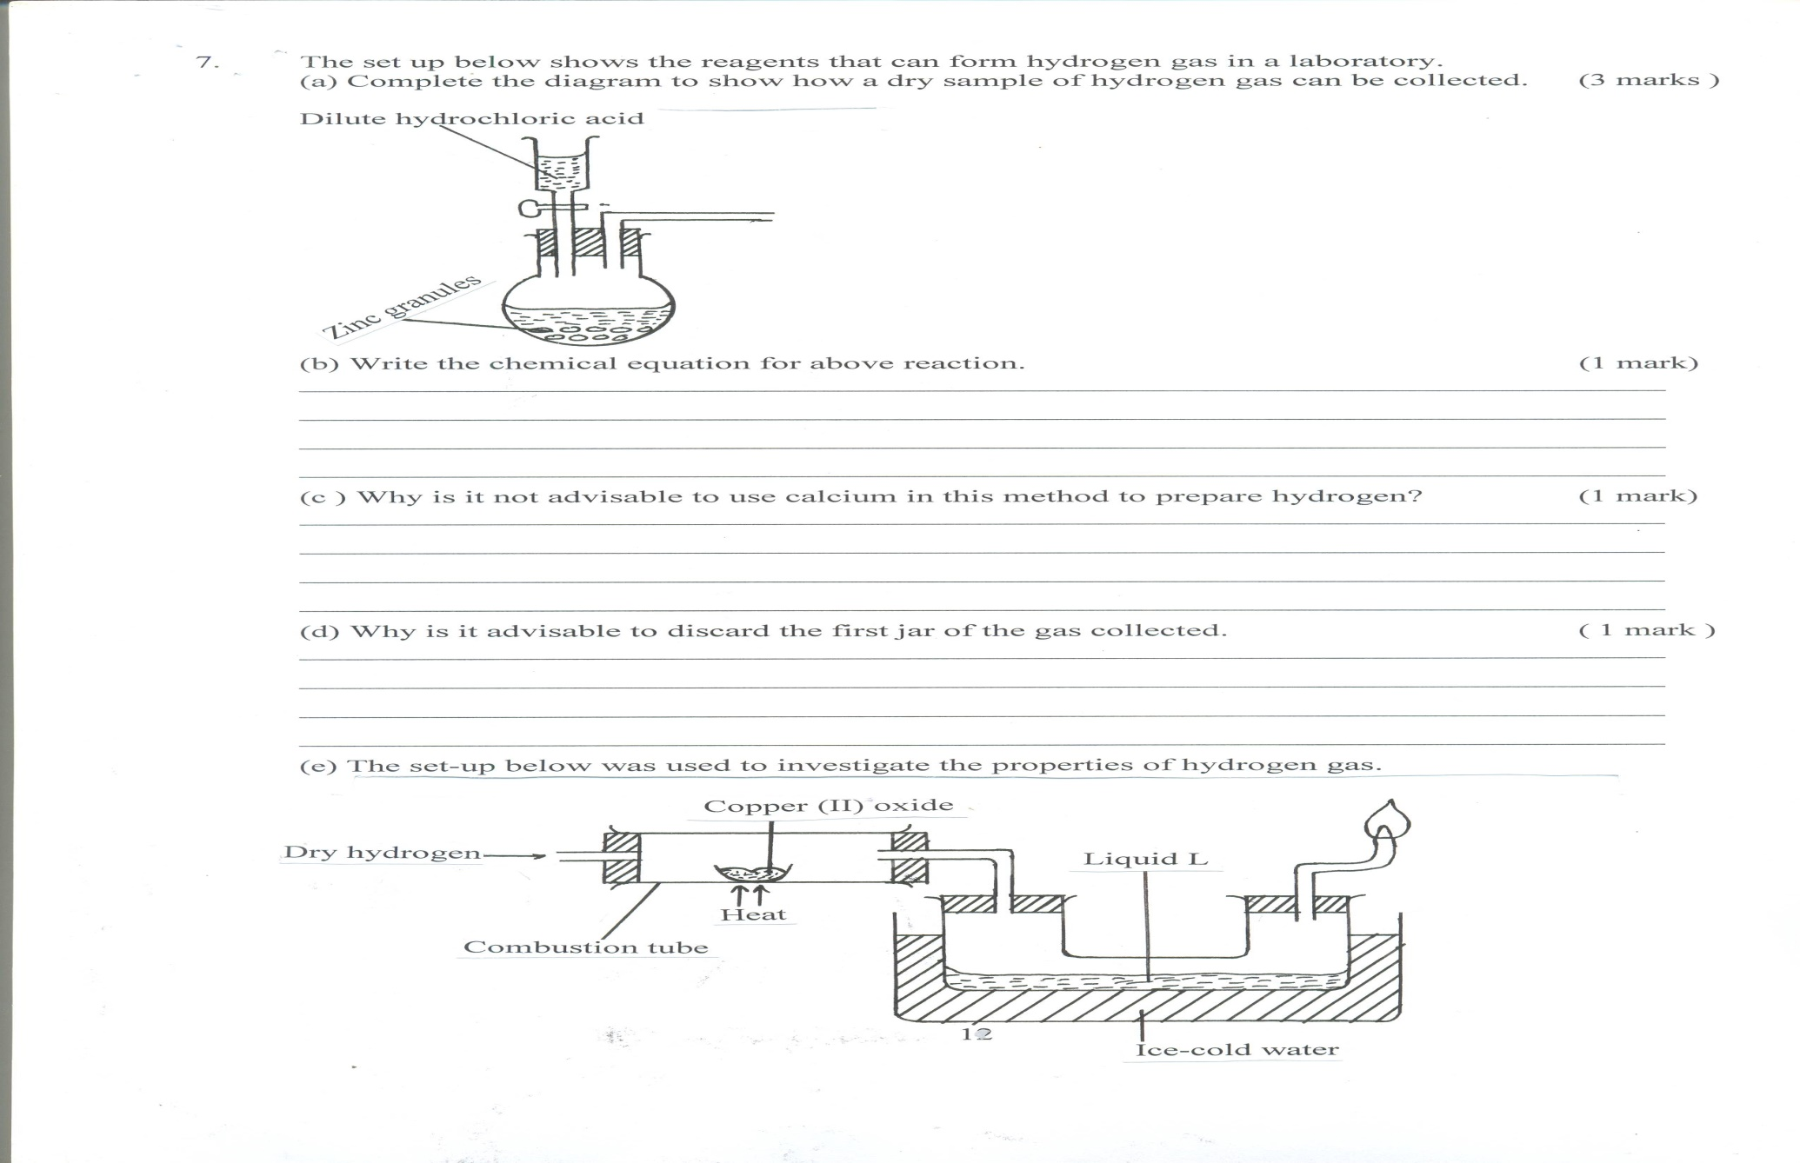

(b) Write the chemical equation for above reaction. (1 mark)

(c ) Why is it not advisable to use calcium in this method to prepare hydrogen? (1 mark)

(d) Why is it advisable to discard the first jar of the gas collected. ( 1 mark )

(e) The set-up below was used to investigate the properties of hydrogen gas.

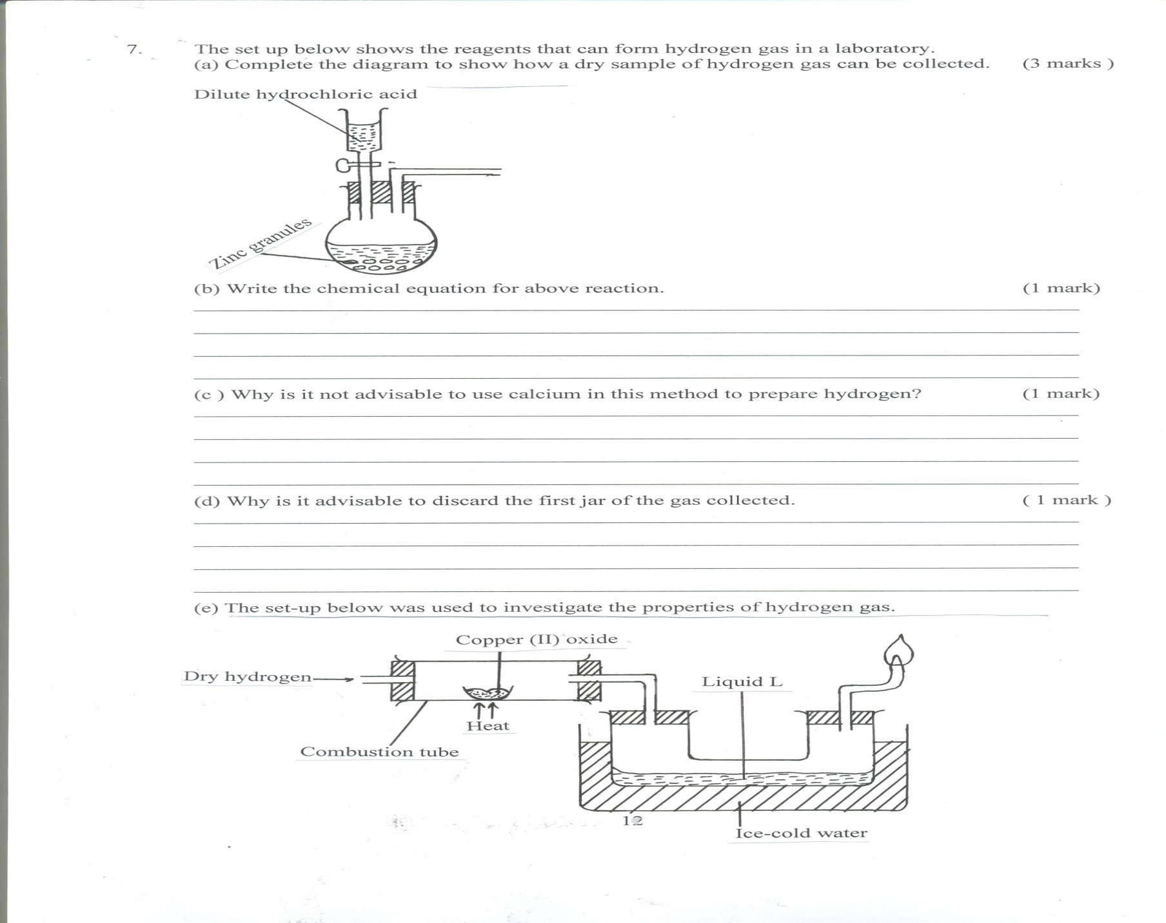

(i) State the observation made in the combustion tube. (1 mark )

(ii) Write down the equation leading to formation of liquid L. (1 mark)

(iii) What property of hydrogen is being investigated. (1 mark )

(iv) Why is potassium oxide not used to investigate this property of hydrogen gas. (1 mark)

(v) Hydrogen gas is used in hydrogenation of oils. What do you understand by the term hydrogenation? (1 mark)

(vi) Give any 2 other industrial uses of hydrogen gas. (1 mark)

**35**.(a) The flow chart below shows a sequence of reactions starting with iron.

Study it and answer the questions that follow.

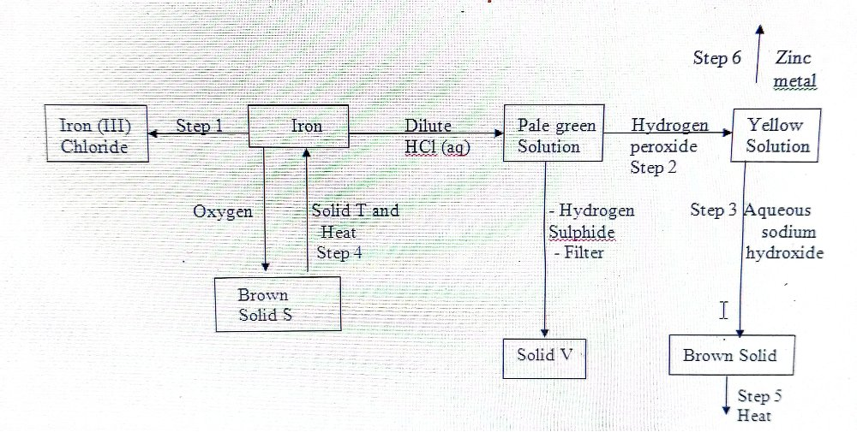 (i) Name the reagent and state the conditions for the reaction in step 1.

Reagent _____________________________________ (1 mark)

Condition _______________________________________________________(1 mark)

(ii) Give the names of the following

(i) Solid S __________________________________________ (1 mark)

(ii) Solid T _________________________________________ (1 mark)

(iii) Solid V ________________________________________ (1 mark)

(iii) Explain the colour changes in step 2. (2 marks)

(iv) Write an ionic equation for the reaction in step 3. (1 mark)

(v) Name one other substance that could be used instead of sodium hydroxide. (1 mark)

(vi) Give the names of the types of the reactions that took place in steps 2 and 3.

Step 2 (1 mark)

Step 3 (1 mark)

(b) In an experiment, 3.36g of iron filling were added to excess aqueous copper (II) sulphate.

(i) State two observations made in the reaction above. (1 mark)

(ii) Calculate the mass of solid formed. (Cu = 64, S = 32. Fe = 56 ) (3 marks)

**36**.Study the information in the table below and answer the questions that follow.The letters do not represent the actual symbols of the elements.

|  |  |  |  |  |  |
| --- | --- | --- | --- | --- | --- |
| Element | Atomic number | Formula of oxide | Melting point(oC) | Formula of chloride | Melting point(oC) |
| P | 11 | P2O | 1193 | PCl | 801 |
| Q | 12 | QO | 3075 | QCl2 | 714 |
| R | 13 | R2O3 | 2045 | RCl3 | 178 |
| Y | 14 | YO2 | 1728 | YCl4 | -70 |
| T | 15 | T2O5 | 568 | TCl5 | 16 |
| V | 17 | V2O7 | -91 | Cl2 | -101 |

1. Explain why the melting of YO2 is higher than that of V2O7. (2 marks)
2. Compare conductivity of element R with that of element P.Explain. (2 marks)
3. Why is it RCl3 has a lower melting point compared to that of R2O3. (2 marks)
4. Compare the sizes of T and V.Explain. (2 marks)
5. Identify a chloride that will dissolve in water giving a neutral solution. (1 mark)
6. Identify an oxide that can be used in making the lining of furnaces.Explain. (2 marks)

**37**.Crude oil is a mixture of hydrocarbons which are separated by fractional distillation one of the components obtained contains an alkane A with eleven carbon atom.

1. Write the molecular formula of A. (1 mark)
2. Pentane can be obtained from compound A as shown

A pentane +B

1. Give the name of this conversion process. (1 mark)
2. State the condition used in this process. (1 mark)
3. Give the name of compound B. (1 mark)
4. Draw and name **two** isomers of pentane (4 marks)
5. Incomplete combustion of pentane may result in air pollution. Write an equation to illustrate this combustion. (1 mark)
6. In the laboratory, methane can be prepared from salts of alkanoic acids. Describe how methane is prepared from sodium ethanoate. (3 marks)

**38**.The scheme below demonstrates some of the chemical properties of ammonia.Use it to answer the questions below.

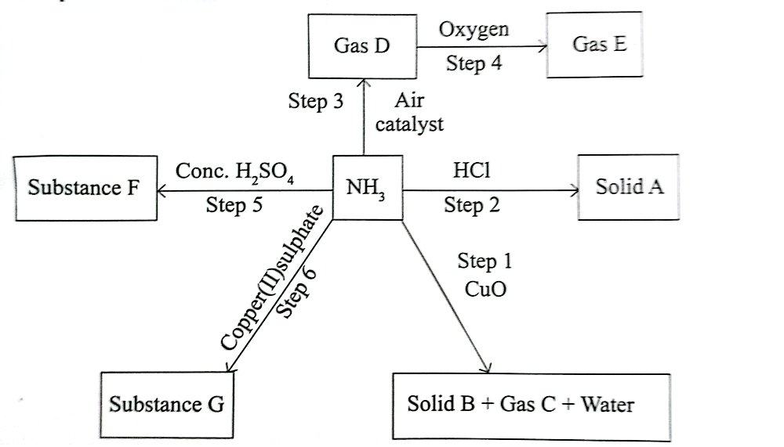

1. Identify:
2. Solid A. (1 mark)
3. Gas D. (1 mark)
4. Gas C. (1 mark)
5. State observations made in the steps indicated below.
6. Step 1. (1 mark)
7. Step 2. (1 mark)
8. Step 4. (1 mark)
9. Step 6. (1 mark)

(c ) (i) Write equation for the formation of substance F. (1 mark)

(ii) State **one** use of substance F. (1 mark)

(d ) State and explain observations made when solid A is heated in a boiling tube. (2 marks)

**39.**1cm3 of 2M aqueous ammonia was added to 10cm3 of 2M lead II nitrate solution.After shaking and allowing it to stand for 15 minutes after which the height of the precipitate was determined.The experiment was repeated using different volumes of 2M aqueous ammonia and the data recorded as shown in the table.

|  |  |  |  |  |  |  |  |  |
| --- | --- | --- | --- | --- | --- | --- | --- | --- |
| Volume of 2M NH4OH(aq) | 1 | 2 | 3 | 4 | 5 | 6 | 7 | 8 |
| Height (mm) | 3 | 6 | 9 | 10 | 15 | 18 | 18 | 18 |

(a ) Plot a graph of height against volume. (3 marks)

(b ) Explain the shape of the graph. (2 marks)

(c ) Calculate the number of moles of 2M aqueous ammonia in 6cm3 of the solution. (2 marks)

(d ) Write an equation for the reaction between ammonium hydroxide solution and lead (II) nitrate solution. (1 mark)

(e ) Determine the number of moles of lead (II) nitrate required to react completely with 6cm3 of 2M aqueous ammonia solution. (1 mark)

**40**.The flow chart below shows industrial preparation of sulphuric (VI) acid.Study it and answer the questions that follow.

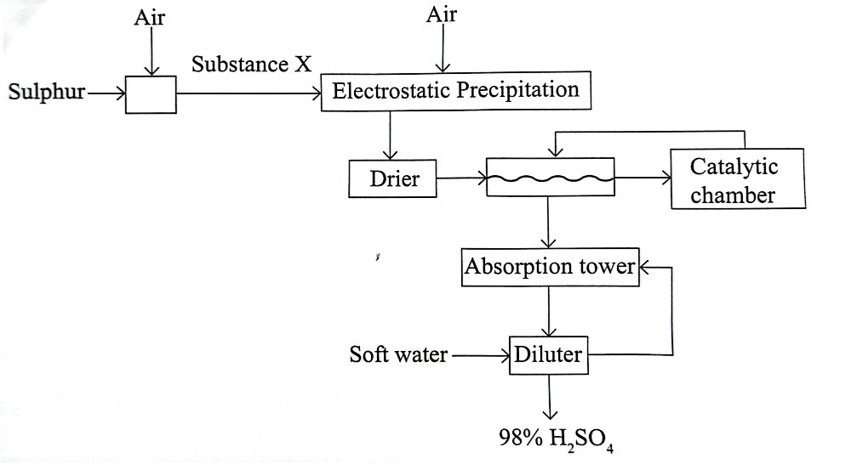

(a ) Write the equation for the reaction leading to formation of substance X. (1 mark)

(b ) Name **two** of the substances eliminated by the electrostatic precipitation. (2 marks)

(c ) What is the function of a drier? (1 mark)

(d ) Name the most suitable catalyst that can be used in the catalytic chamber. (1 mark)

(e ) Why is the product of the catalytic chamber not dissolved directly using water? (1 mark)

(f ) Write an equation of the reactions taking place in the:

1. Catalytic chamber. (1 mark)
2. Absorption tower. (1 mark)
3. Diluter. (1 mark)

(g ) State any **two** uses of sulphuric VI acid. (1 mark)

**41**.The following flow chart shows the chemical properties of hydrochloric acid.Study the diagram and answer the questions that follow.

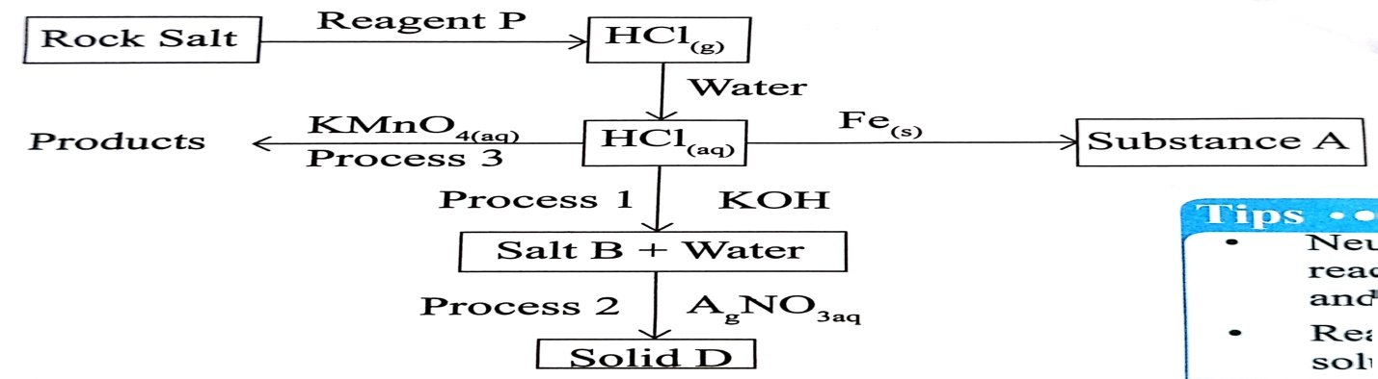

(a) Name processes 1 ,2 and 3.

(b) Identify substance A and salt B.

(c ) (i) State conditions for the reaction leading to the formation of hydrogen chloride.

(ii ) Write an equation of reaction between reagent P and rock salt.

(d ) State the observations made in process 2.

(e ) (i) Write the chemical equation for the reaction taking place in process 3.

(ii ) Write the ionic equation leading to the formation of solid D.

(f ) State one industrial use of hydrochloric acid.

**42**.Study the reaction scheme below and answer the questions that follow.

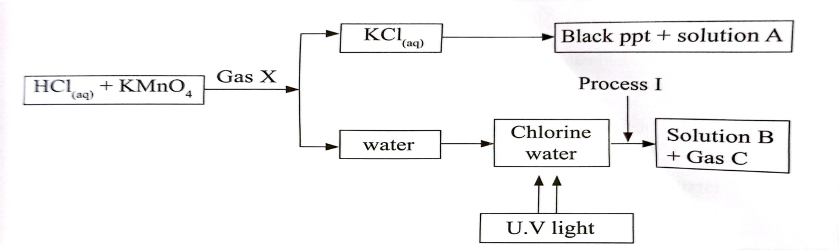

1. Identify

Gas X Solution A Solution B Gas C Process I

(b ) Write equation of reaction leading to formation of gases X and C and the black precipitate.

(c ) State observations made upon exposure of gas C to nitrogen II oxide.

**43**.Study the flow chart below and answer the questions that follow.

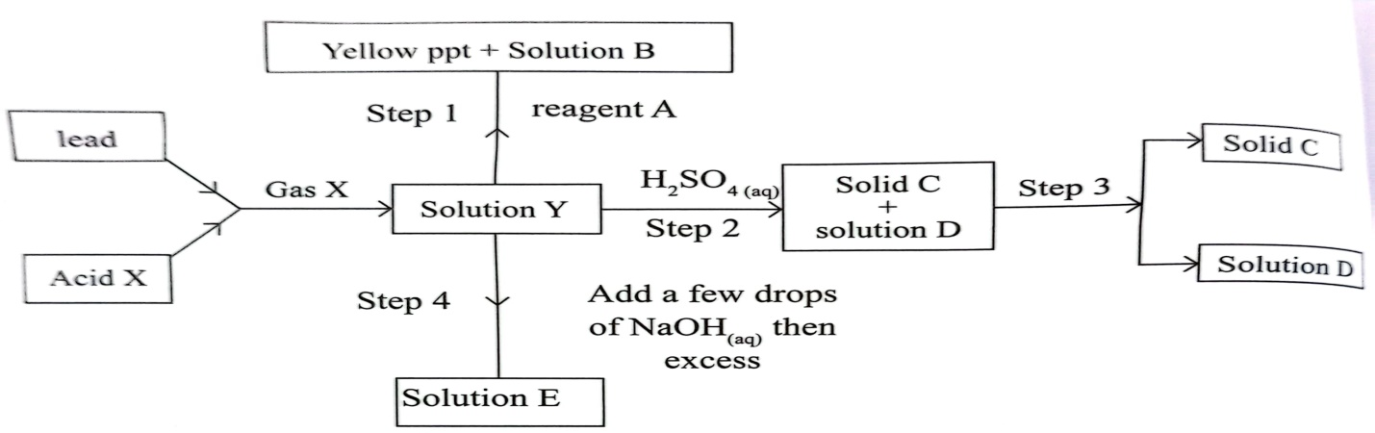

1. Identify substances

B C D E Acid X

(b ) Write ionic equations for the reactions that take place in:

1. Step 1
2. Step 4

(c ) State and explain observations for the reactions that take place in step 4.

(d ) Identify the method employed to separate solid C from solution D in step 3.

**44**.The flow chart below shows the chemical properties of hydrogen sulphide.Study the diagram and use it to answer questions that follow.

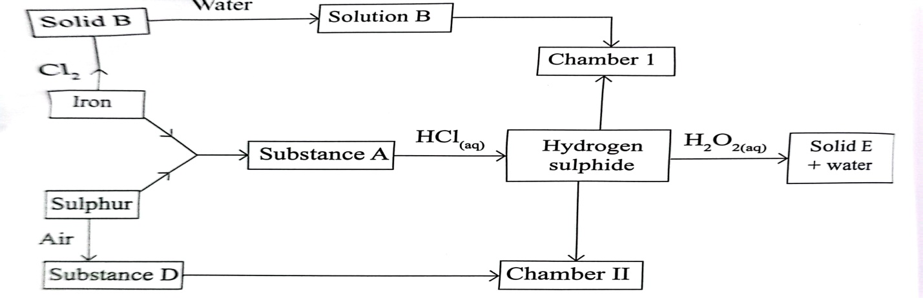

(a ) Identify:

1. Substance A
2. Substance B
3. Substance D

(b ) Write equation for the reaction between substance A and hydrochloric acid.

(c ) Explain observations made in:

1. Chamber I
2. Chamber II

(d ) Write equation leading for formation of solid E.

(e ) State one industrial use of solid E.

**45**.The scheme shows some of the properties of the iron metal.Use it to answer the questions that follow.

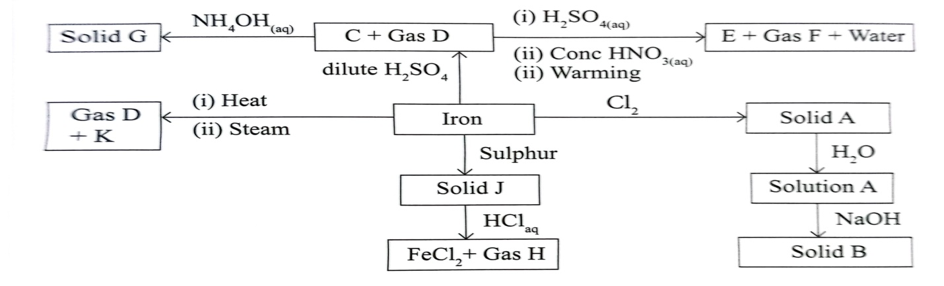

1. Identify
2. Solid B
3. Solid J
4. Substance E
5. Gas F

(b ) Write equations for the reactions forming:

1. Substance K.
2. Substance C
3. Solid G

(c ) State how one can:

1. Test for Gas D.
2. Take precaution in collecting gas H.

(d )(i) What observations are made when solid A is subjected to heat?

(ii ) What observations are made when sulphur IV oxide is bubbled into solution A?

**46**.In an experiment to prepare ammonia gas ,ammonium chloride and slaked lime were heated for some time under standard conditions of temperature and pressure.0.112 litres of ammonia were collected and then reacted completely with 225 cm3 of nitric V acid.

(a ) Write the equation of the reaction between ammonium chloride and slaked lime.

(b ) Draw a well labeled diagram of how ammonia gas is dried and collected.

(c ) Suggest how one can determine that the gas jar is full of ammonia.

(d ) Calculate the number of moles of ammonia gas that were collected in the above experiment given that 1 mole of the gas occupies 22.4dm3 at s.t.p.

(e )(i) Write an equation for the reaction between ammonia and nitric V acid.

(ii ) Calculate the maximum mass of ammonium nitrate obtained in the experiment.

**47**.The flow chart below shows the chemical properties of sulphur IV oxide.Study the flow diagram and answer the questions that follow.

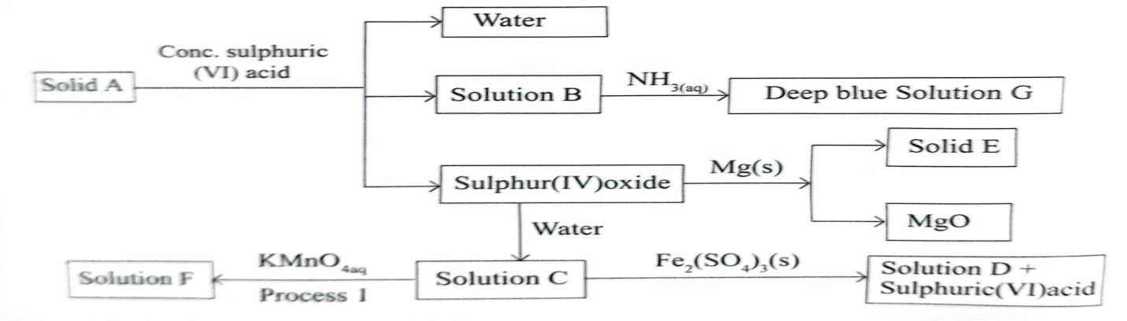

(a ) Name the following substances

1. Solution C
2. Solution D
3. Solid E
4. Solution F

(b ) Explain the observation made when red mitmus is dropped in solution C.

(c ) Write equation of reaction between solid A and concentrated sulphuric VI acid.

(d ) Identify process I.

(e ) State the conditions necessary for the reaction taking place in process 1

(f ) Write the formula of the ion responsible for the deep blue colour in solution G.

**48**.Study the scheme below and answer the questions that follow.

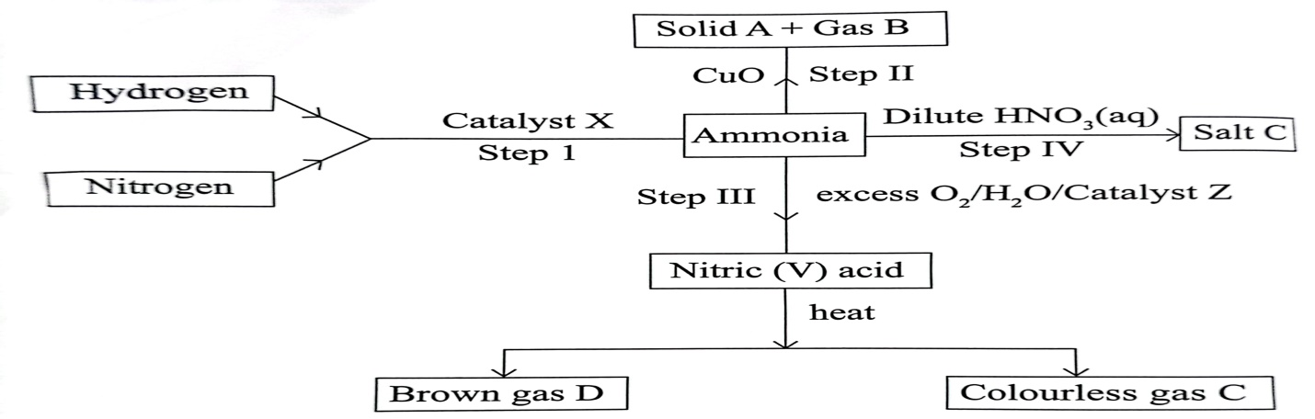

(a ) Name:

1. Catalyst X
2. Catalyst Z
3. Gas C
4. Gas D

(b ) Write equations of reactions taking place in steps I ,II ,III and IV.

(c ) Explain why it is necessary to have excess oxygen in step III.

(d ) State conditions necessary for step I.

(e ) Identify sources of hydrogen and nitrogen used in the reaction.

(f ) State one use of:

1. Salt C
2. Nitric V acid.

(g ) Why is it necessary to store nitric V acid in dark bottles?

**49**.Study the flow chart below and answer the questions that follow.

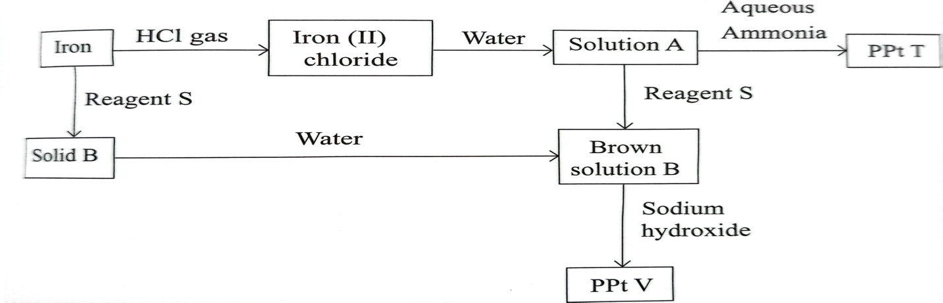

(a ) Name:

1. Solution A
2. Reagent S

(b )(i) Explain the observation leading to formation of solution B after reagent S reacted with solution A.

(ii ) Write an ionic equation for the reaction in (b)(i) above.

(c ) Write equations leading to the formation of:

1. Precipitate T.
2. Precipitate V
3. Iron II chloride.
4. Solid B.

**50**.The flow chart shows the chemical properties of chlorine.Study it and answer the questions that follow.

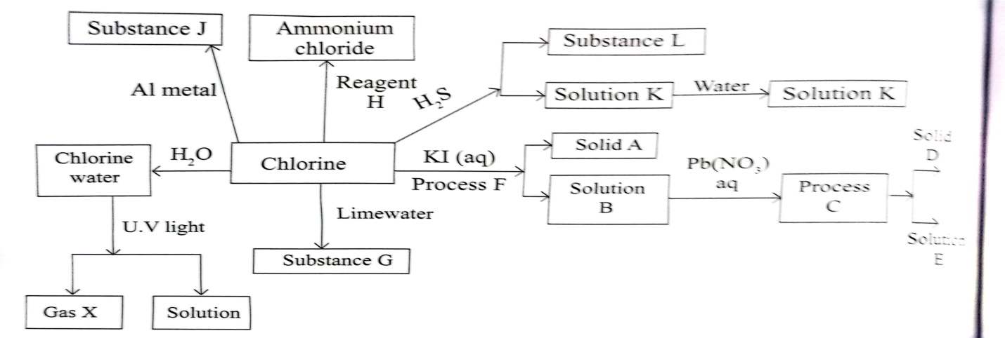(a ) Identify processes

1. C
2. F

(b ) Write ionic equations between lead II nitrate and solution.

(c ) Name substances:

1. Solid D
2. Solution E
3. Solution K
4. Reagent H

(d ) Identify each of the substances listed below and state one use of each

1. Substance L
2. Solid A

(e ) (i) Write equation leading to formation of substance G.

(ii ) State one use of substanece G.

(f )(i) Write equation leading to formation of Gas X.

(ii ) State a common test for gas X.

(g ) (i) State some physical properties of substance J.

(ii ) Name another metal that would portray similar properties if it was used in place of aluminium.

(h ) State one industrial use of chlorine.