**NAME:…………………………………………………………… ADM. NO…………………………..…..…..**

**SCHOOL:……………………………………………………SIGNATURE……………………………… DATE…………….……………………………….**

**231**

**BIOLOGY**

**(Theory)**

**TIME: 2HOURS**

**SET 1**

**FORM 1**

**INSTRUCTIONS TO CANDIDATES**

* Write your name and Adm. number in the spaces provided.
* Answer ALL the questions in the spaces provided,

**FOR EXAMINERS USE ONLY**

|  |  |  |
| --- | --- | --- |
| Question | Maximum score | Candidates score |
| 1-14 | 70 |  |

***Candidates should check the question paper to ensure that all the pages are printed as indicated and no questions are missing.***

1. Define the following terms; **(2 marks)**
2. Taxonomy

…………………………………………………………………………………………………………..………………………………………………………………………………………………………….…………………………………………………………………………………………………………..

1. Binomial nomenclature

………………………………………………………………………………………………………………………………………………………………………………………………………………………………………………………………………………………………………………………………

1. Some form one students wanted to collect the following animals for study in the laboratory.

Name the suitable apparatus they use for; **(4 marks)**

1. Crawling animals …………………………………………………………………………….
2. Flying insects………………………………………………………………………………….
3. Small animals from tree barks ……………………………………………………………….
4. Crawling stinging insects …………………………………………………………………….
5. State **four** reasons why classification is important in biology. **(4 marks)**

…………………………………………………………………………………………………………………………………………………………………………………………………………………………………………………………………………………………………………………………………………………………………………………………………………………………………………

1. Identify the discipline of biology that deals with the following.
2. The relationship between organisms and their environment. **(1 mark)**

…………………………………………………………………………………………………

1. Study of development of living organisms. **(1 mark)**

…………………………………………………………………………………………………

1. Study of body functions of living organisms. **(1 mark)**

…………………………………………………………………………………………………

1. Specialization in the study of chemical changes in an organism. **(1 mark)**

…………………………………………………………………………………………………

1. Study of structure of living things. **(1 mark)**

…………………………………………………………………………………………………..

1. Study of microscopic organisms. **(1 mark)**

…………………………………………………………………………………………………..

1. Study of inheritance and variation. **(1 mark)**

…………………………………………………………………………………………………..

1. What scientific skills do people who study biology acquire. **(4 marks)**

…………………………………………………………………………………………………………

…………………………………………………………………………………………………………………………………………………………………………………………………………………………………………………………………………………………………………………………………………………………………………………………………………………………………………

…………………………………………………………………………………………………………

1. Explain why the following processes are essential in living organisms. **(3 marks)**
2. Irritability

……………………………………………………………………………………………………………………………………………………………………………………………………………………………………………………………………………………………………….

…………………………………………………………………………………………………

1. Excretion

………………………………………………………………………………………………………………………………………………………………………………………………………………………………………………………………………………………………………

…………………………………………………………………………………………………

1. Respiration

……………………………………………………………………………………………………………………………………………………………………………………………………………………………………………………………………………………………………….

1. The diagram below represents common laboratory equipment.

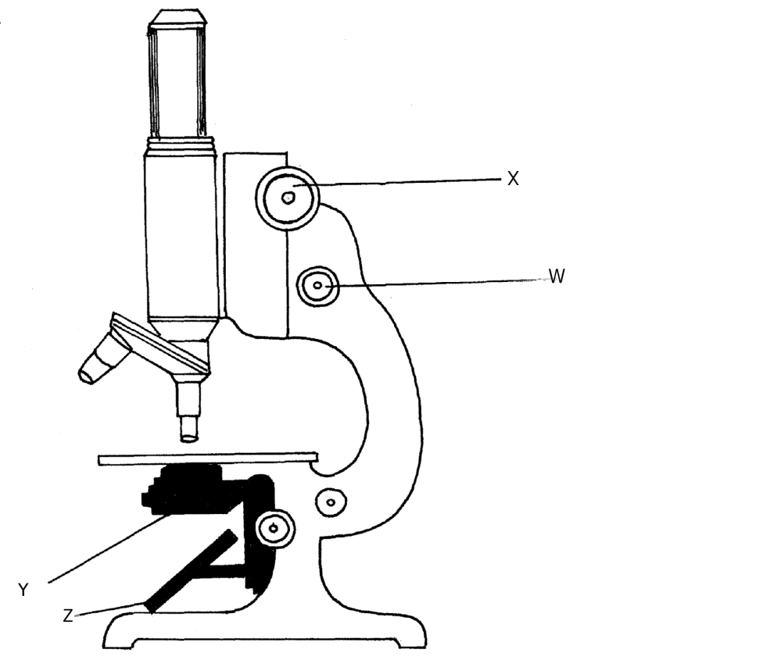

Label the parts labeled W, X, Y and Z  **(4 marks)**

W………………………………………………………...

X ………………………………………………………..

Y……………………………………………………….

Z……………………………………………………….

1. Name the taxonomic units of classification from the highest and largest to lowest and smallest.

**(7 marks)**

……………………………………………………………………………………………………………………………………………………………………………………………………………………………………………………………………………………………………………………………………………………………………………………………………………………………………………………………………………………………………………………………………………………………….………………………………………………………………………………………………………………………………………………………………………………………………………………….…………………………………………………………………………………………………

1. State **four** reasons why studying biology is important. **(4 marks)**

………………………………………………………………………………………………………….

……………………………………………………………………………………………………………………………………………………………………………………………………………………………………………………………………………………………………………………………………………………………………………………………………………………………………………………………………………………………………………………………………………………

…………………………………………………………………………………………………………

1. Why are cattle regarded as animals and not plants? **(4 marks)**

………………………………………………………………………………………………………………………………………………………………………………………………………………………………………………………………………………………………………………………………………………………………………………………………………………………………………………………………………………………………………………………………………………………………………………………………………………………………………………………………

1. What precautions should be taken during collection and observation of specimens in the laboratory?

**(4 marks)**

………………………………………………………………………………………………………………………………………………………………………………………………………………………………………………………………………………………………………………………………

1. Examine the diagram below carefully and use it to answer the questions that follow.

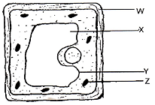

Namethe parts labeled X, Y, and Z **(4 marks)**

W………………………………………………

X……………………………………………….

Y………………………………………………

Z……………………………………………….

1. State **five** professional occupations that require the study of biology. **(5 marks)**

……………………………………………………………………………………………………………………………………………………………………………………………………………………………………………………………………………………………………………………………………………………………………………………………………………………………………

1. A motor vehicle is able to move, break fuel to carbon (IV) oxide and water yet it is not classified as a living thing. State other characteristics of living things that are not shown by the motor vehicle.

**(4 marks)**

…………………………………………………………………………………………………………………………………………………………………………………………………………………………………………………………………………………………………………………………………………………………………………………………………………………………………………………………………………..