**Name: ________________________________________ Adm No: __________Class:________**

**Candidate’s Signature**: ________________________ **Date**: __________________________

**GITHUMU HIGH SCHOOL**

**MATHEMATICS**

**FORM 2**

**OCTOBER/NOVEMBER/DECEMBER 2024 HOLIDAY ASSIGNMENT**

1. Evaluate (3mks)

2. Solve for x in the equation: 3(x-2) ×81x=243 (3mks)

3. Use tables of reciprocals to work out: (3mks)

4. Take a number p, double it and add 5 to the result. If the result is doubled again, the new number is 22. Find p. (3mks)

5. The shaded region in the figure below swept out on a flat windscreen by a wiper. Calculate the area of the region. (4mks)

16cm

120o

4cm

6. Given that Cos (x-20)0 =Sin (2x+32)0 and that x is an acute angle, find tan(x-4)0  (3mks)

7. Use elimination method to solve the simultaneous equation below (3mks)

5x+3y=1

3x=2y+8

8. A Kenyan company received US Dollars 100000.the money was converted into Kenyan shillings in a bank which buys and sells foreign currencies as follows.

|  |  |  |
| --- | --- | --- |
|  | Buying(Ksh) | Selling(Ksh) |
| 1 UD Dollar | 77.24 | 77.44 |
| 1 Sterling Pound | 121.93 | 122.27 |

a) Calculate the amount of money in Ksh. The company received (2mks)

b) The company exchanged the Kenyan shillings calculated in (a) above into sterling pounds to buy a car from Britain, calculate the cost of the car to the nearest sterling pound (2mks)

9. The marked price of a TV set in a shop is Ksh 40000. Mueni bought the TV at 10% discount and the shopkeeper still made a profit of 20%. Calculate the amount of money the shopkeeper paid for the TV. (3mks)

10. The GCD and LCM of three numbers are 3 and 1008 respectively. If two of the numbers are 48 and 72, find the least possible value of the third number. (3mks)

11. In the figure below ABCD is a trapezium in which AD id parallel to BC. Given that AD= 25cm, BC = 15cm

And angle DAB=60o, calculate the area of the trapezium. (3mks)

B

E

25cm

H

60o

C

D

15cm

A

12. A straight line L1 passes through T (-2, 1) and is perpendicular to another line L2 whose equation is 2x-3y+4=0. Find the equation of L1 in the form y=mx+c where m and c are constants (3mks)

13. The size of an interior angle of a regular polygon is 1560 .find the number of sides of the polygon. (2mks)

**SECTION II: 30 MARKS**

14. A straight line L1 has a gradient - $\frac{1}{2}$ and passes through point P (-1, 3). Another line L2 passes through the points Q (1, -3) and R (4, 5). Find:

a) The equation of L1 (2mks)

b) The equation of L2 in the form ax + by + c = 0. (3mks)

c) The equation of a line passing through a point S (0, 5) and is perpendicular to L2. (3mks)

d) The equation of a line through R parallel to L1. (2mks)

15. The figure below shows a frustum. The top and bottom radii are 5cm and 10cm respectively, while the vertical height of the frustum is 12cm.

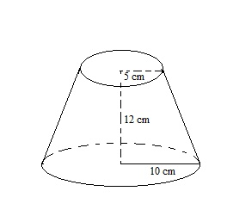

Find the: -

a) Slant height of the frustum. (3marks)

b) Curved area of the frustum. (3marks)

c) Volume of the frustum. (4marks)

16. The diagram below shows two circles, centre A and B which intersect at points P and Q. Angle PAQ = 700 and PBQ = 400 and PA = AQ = 8cm.

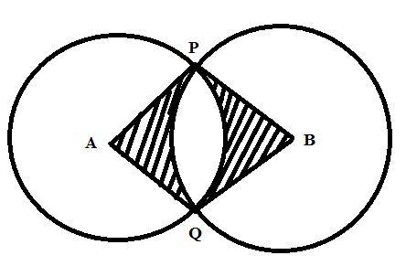

Use the diagram to calculate to two d.p

a) The length PQ (2marks)

b) The length PB (2marks)

c) Area of minor segment circle centre A. (2marks)

d) Area of the shaded region. (4marks)

17. The coordinates of a triangle ABC are A (1, 1), B (3, 1) and C (1, 3).

(a) Plot the triangle ABC. (1mk)

(c) ABC undergoes a reflection along the line x = 0, obtain the coordinates and plot on the graph points A’ B’ C’, under the transformation (3mks)

(d) The triangle A’ B’ C’, undergoes an enlargement scale factor -1, centre origin. Obtain the coordinates of the image A’’ B’’ C’’ (3mks)

(e) The triangle A’’ B’’ C’’ undergoes a rotation centre (1, -2) angle 1200. Obtain the coordinates of the image A’’’B’’’C’’’ . (3mks)

18. The figure below represents a piece of land consisting of a trapezoidal region and a semi-circular end of radius 87.5m

250m

200m

a) Calculate:

i )The perimeter of the land (3marks)

ii) The area of the land in hectares (3marks)

b) A private developer bought this piece of land at a price of Ksh 400,000 per hectare and later sold the all land at 2.25 million shillings. Determine;

i) The price at which he bought the whole piece of land (2marks)

ii) His percentage profit (2marks)