**Name:** _____________________________________________ **Adm No:** ____________**Class**: _____

**Name: ________________________________________ Adm No: __________Class:________**

**Candidate’s Signature**: ________________________ **Date**: __________________________

**GITHUMU HIGH SCHOOL**

**MATHEMATICS**

**FORM 3**

**OCTOBER/NOVEMBER/DECEMBER 2024 HOLIDAY ASSIGNMENT**

**PAPER 1**

***SECTION I***

1. Simplify the expression. $\frac{6X^{2}+35X-6}{X^{2}-36}$ (3 Marks)

1. The ratio of the lengths of the corresponding sides of two similar rectangular water tanks is 3:5. The volume of the smaller tank is 8.1m2. calculate the volume of the larger tank (3 Marks)
2. Express 5. $\dot{5}$ as a mixed number. (3 Marks)
3. Sixteen men working at the rate of 9hrs a day can complete a piece of work in 14 days. How many more men working at the rate of 7 hours a day would complete the same job in 12 days (3 Marks)
4. Evaluate $\frac{1\frac{4}{5}÷\frac{2}{3}of2\frac{1}{4}-\frac{3}{10}}{\frac{5}{6}+\frac{22}{39}×1\frac{2}{11}}$ (4 marks)
5. The interior angle of a regular polygon is 108o larger than the exterior angle. How many sides has the polygon? (3 Marks)
6. Mr.Wanyama has a plot that is in a triangular form. The plot measures 170m, 190m and 210m, but the altitudes of the plot as well as the angles are not known. Find the area of the plot in hectares. (3 Marks)
7. A Japanese tourist entered Kenya with Kshs.500,000 Japanese Yen which he converted to Kenya currency. While in Kenya, he spend Kshs.16200 in all. He then converted all the remaining money into Euros before leaving for Italy. If he carried out all his transactions at the Stanbic bank using rates shown below, calculate to the nearest Euro, how much money he left Kenya with. (***Do not use mathematical tables for this question).*** (3 Marks)

|  |  |  |
| --- | --- | --- |
|  | **Buying (Kshs)** | **Selling Kshs)** |
| **100 Japanese Yen** | 66.35 | | 66.05 |
| **1 Euro** | 78.15 | | 77.85 |

1. Solve the equation 9 x+1 3 2x + 1= 243 (3 Marks)
2. Use mathematical table to evaluate. (4 marks)

2849 x 0.00574

4

36.89 ÷ 0.023

1. By use of matrix method, solve the simultaneous equations; (3 Marks)

6x + 4y = 36

x + 3y = 13

1. Wangechi whose eye level is 182cm tall observed the angle of elevation to the top of her house to be 32º from her eye level at point A. she walks 20m towards the house on a straight line to a point B at which point she observes the angle of elevation to the top of the building to be 40º. Calculate, correct to 2 decimal places the

a) distance of A from the house (3 Marks)

b) The height of the house (1 Marks)

1. Given that tan **x** = $\frac{5}{12}$ find the value of the Cos (90-x) without using mathematical tables or calculator. (2 Marks)
2. Given that:- r = 5i – 2j and m = -2i + 6j – k are the position vectors for R and M respectively. Find the length of vector RM (3 Marks)

~

~

~

~

~

~

~

~

1. The equation of a line is $\frac{3}{5}x+3y=6$. Find the equation of a line passing through point (1,2) and perpendicular to the given line. (3 Marks)

1. Draw the solid whose net is shown below. (3 Marks)

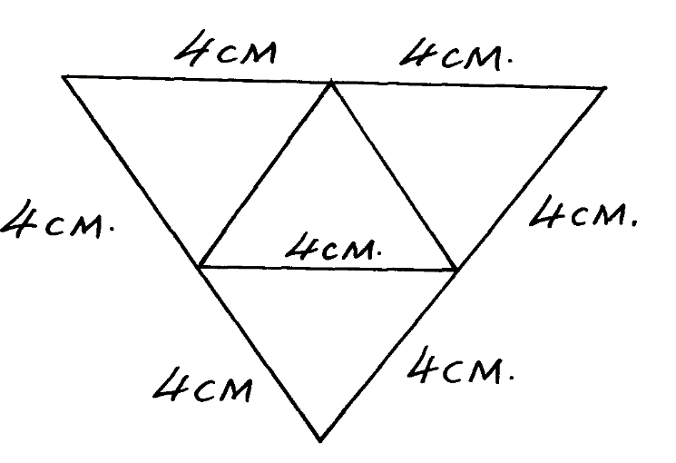

4cm

4cm

4cm

4cm

4cm

4cm

4cm

**SECTION II (50 MARKS)**

1. a) Complete the table for the function **y = 1 – 2x – 3x2** for **-3 ≤ x ≤ 3.** (2 Marks)

|  |  |  |  |  |  |  |  |
| --- | --- | --- | --- | --- | --- | --- | --- |
| **x** | -3 | -2 | -1 | 0 | 1 | 2 | 3 |
| **y** | -20 |  |  | 1 |  | -15 |  |

b) Using the table above, draw the graph of **y = 1 – 2x – 3x2** (Scale 1 cm represent 0.5 units on **x-axis** and 1 cm rep 4 units on the **y – axis** on the grid provided. (3 marks)

c) Use the graph in **(b)** above to solve.

(i) **1 – 2x – 3x2 = 0** ( 2 Marks)

(ii) **2 – 5x – 3x2 = 0** (3 Marks)

1. The diagram below shows the speed-time graph for a bus traveling between two towns. The bus starts from rest and accelerates uniformly for 50seconds. It then travels at a constant speed for 150seconds and finally decelerates uniformly for 100seconds.

***Speed m/s***

***Time in seconds***

Given that the distance between the two towns is 2700m, calculate the ; a) maximum speed the bus attained

1. m/s (3 Marks)
2. km/h (1Marks)

(b) acceleration (2 Marks)

(c) distance the bus traveled during the last 50seconds ( 2 Marks)

(d) time the bus takes to travel the first half of the journey. ( 3 Marks)

1. Three businessmen Langat, Korir and Koech contributed shs.160,000, Shs.200,000 and shs.240,000 respectively and started a business. They agreed that 30% of the profit each year will go to expenses, 15% of the reminder would go back to the business. The rest of the profit would be shared in the ratio of their contribution. At the end of the first year, the business realized a profit of kshs.60,000.

Calculate how much;

(a) (i) Langat received ( 4 Marks)

(ii) Korir received ( 2 Marks)

(iii) Koech received ( 2 Marks)

(b) Express what Korir received as a percentage of the total profit ( 2 Marks)

1. Four ships are at sea such that a streamliner S is 150km on a bearing of 025° from a cargo

ship **C**. A trawler **T** is 300km on a bearing of 145° from the cargo ship and a yacht **Y** is due

West of **C**  and on a bearing of 300° from **T**.

a) Using a scale of 1cm= 50km, draw on accurate scale drawing showing the positions of S, C, T

and Y. ( 5 Marks)

b) By measurement from your scale drawing determine:

i) The distance and bearing of Y from S ( 3 Marks)

ii) The distance ST (1 marks)

iii) The distance YT ( 1 Marks)

1. The height of 50 athletes in Moi University team were shown below:

|  |  |  |  |  |  |  |
| --- | --- | --- | --- | --- | --- | --- |
| Height (cm) | 150-159 | 160-169 | 170-179 | 180-189 | 190-199 | 200-209 |
| Frequency | 2 | 9 | 12 | 16 | X | 4 |

1. Determine the value of X (2 Marks)
2. State the modal class (1 Mark)

iii) Calculate the mean height of the athletes. (4 marks)

1. Calculate the median height. (3 Marks)
2. 12cm of a cone is chopped off to form a frustrum as shown below. Given that the r=8cm and R =14cm

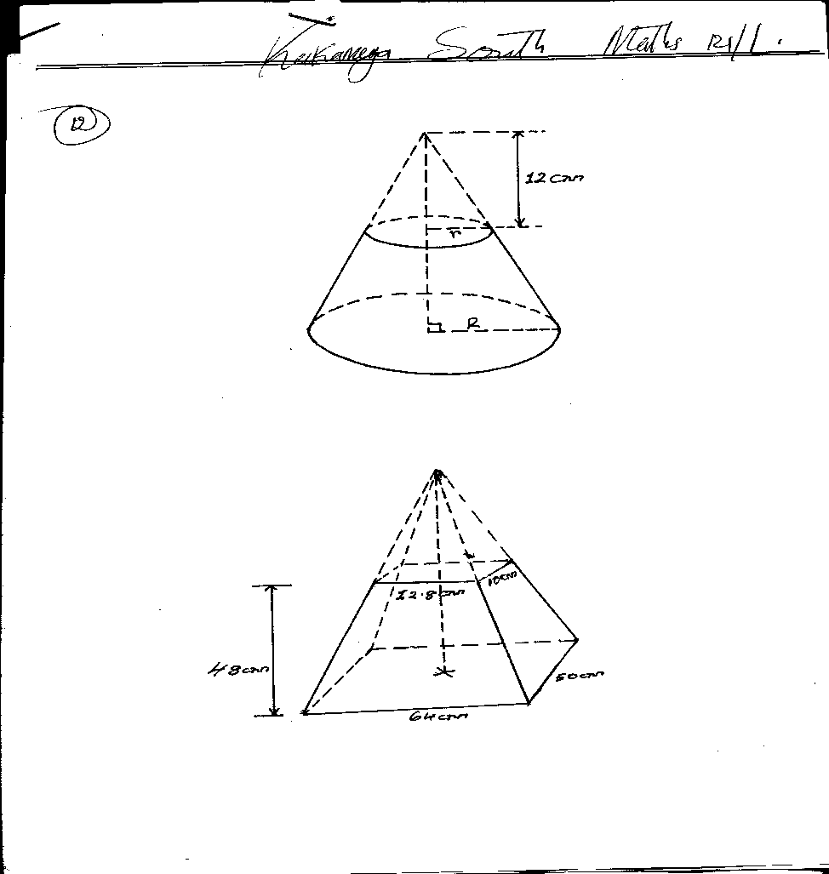

Calculate

1. The height of the cone from which the frustrum was cut. (3marks)
2. The surface area of the frustrum. (use $π=3.142$) (4marks)
3. The volume of the frustum.( use π=3.142) (3marks)
4. a) Plot triangle ABC such that A(1,2), B(2,4) and C(4,3). If triangle ABC is given a rotation centre(0,1) through +900, state the coordinates of the image A’B’C’. Hence plot A’B’C’ on the same axis. (4 Marks)



b) Triangle A’B’C’ is reflected in the line y= -1 to give A’’B’’C’’. State the coordinate of A’’B’’C’’ and plot it on the same axis.

(3 Marks)

c)A’’B’’C’’ is given by an enlargement centre (-5,-7) scale factor 2 to obtain A’’’B’’’C’’’. State the coordinates of A’’’B’’’C’’’ and plot it on the same axis. (3 Marks)

1. Two circles of radii 21cm and 28cm intersect as shown below. Given that length XY=16cm

**X**

**Y**

**B**

**A**

**X**

21cm 28cm

1. Calculate;
2. Angle XAY (2 Marks)
3. Angle XBY (2 Marks)

1. Calculate the area of the shaded region. (6 Marks)

**PAPER 2**

**SECTION I (50 MARKS)**

1.Solve for x in the equation below using the completing the square method. (3 marks)

$x^{2} – 7x + 10 = 0$

2.A rectangular block has a square base whose side is exactly 8cm. Its height measured to the nearest millimetre is 3.1cm. find in cubic centimetres the greatest possible error in calculating its volume (3mks)

3. Simplify  (3mks)

4.P varies partly as the square of V and partly as the cube of V. When V= 2, P = -20 and when V = -3, P = 135. Find the relationship between P and V. (3mks)

5.The second term of a G.P is 6, and the fifth term is 48, find the common ratio and the 3rd term of the G.P. (3mks)

6.Nancy pays for a car on hire purchase in 15 monthly instalments. The cash price of the car is Ksh. 300,000 and the interest rate is 15% p.a. A deposit of Ksh 75,000 is made. Calculate her monthly repayments. (4mks)

7.Solve for θ in the equation 2 sin 2θ = 1 for 0 < θ < 3600. (3mks)

8. Make w the subject of the formula (3mks)

P=

9. Evaluate without using Mathematical tables or a calculator. (3mks)



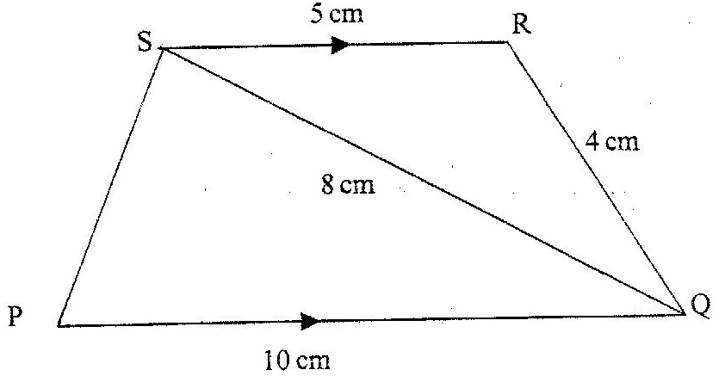10. In the figure below PQRS is a trapezium with SR parallel to PQSR = 5cm, RQ = 4cm, QS = 8cm and PQ = 10cm.

Calculate:

a)The size of angle QSR (2mks)

b)The area of triangle PQS (2mks)

11.The first term of an arithmetic sequence is -5 and the common difference is 3.

a) List the first 5 terms of the sequence. (1 mk)

b) Determine the sum of the first 40 terms of the sequence. (2 mks)

12a) Given the vectors ***a*** = 3***i*** – ***j*** + 2***k***, ***b*** = 4***i*** + 2***j*** – ***k*** and ***p*** = 2***a*** – ***b***. Express ***p*** in terms of ***i***, ***j*** and ***k***. (2mks)

b) Hence calculate $\left|p\right|$ correct to 3 significant figures. (1 mark)

13.A sum of Ksh. 10,000 is invested at 12% p.a compounded quarterly. After how many years will this sum amount to Ksh 24,760? (3marks)

14. The diagram below shows a circle centre O. A point P lies on the line AO such that a tangent from the point P to the circle makes an angle of 300 with the line AO. By construction, locate the point P hence measure the length PO. (3 marks)

A

O

15. Use the tables of reciprocals to evaluate to 3d.p (3 mks)

$\frac{2}{3.53}$ + $\frac{1}{1.758}$

16.Write down the inequalities that defines the unshaded region (3mks)

x

y

0

7

5

7.5

**SECTION II (50 MARKS)**

17. (a) Complete the table below to 2 decimal places. (2mks)

|  |  |  |  |  |  |  |  |  |  |  |  |  |  |
| --- | --- | --- | --- | --- | --- | --- | --- | --- | --- | --- | --- | --- | --- |
| X | 00 | 300 | 600 | 900 | 1200 | 1500 | 1800 | 2100 | 2400 | 2700 | 3000 | 3300 | 3600 |
| – Cos x | – 1 |  | – 0.5 |  | 0.5 | 0.87 |  | 0.87 |  |  | -0.5 | 0.87 |  |
| Sin ( x – 300) |  | 0.0 | 0.5 |  |  | 0.87 | 0.5 |  | – 0.5 |  |  | – 0.87 | – 0.5 |

(b)Draw the graphs of y=sin (x – 300) and y = – Cos x on the same axes, for 00 < x < 3600 ( 5mks)

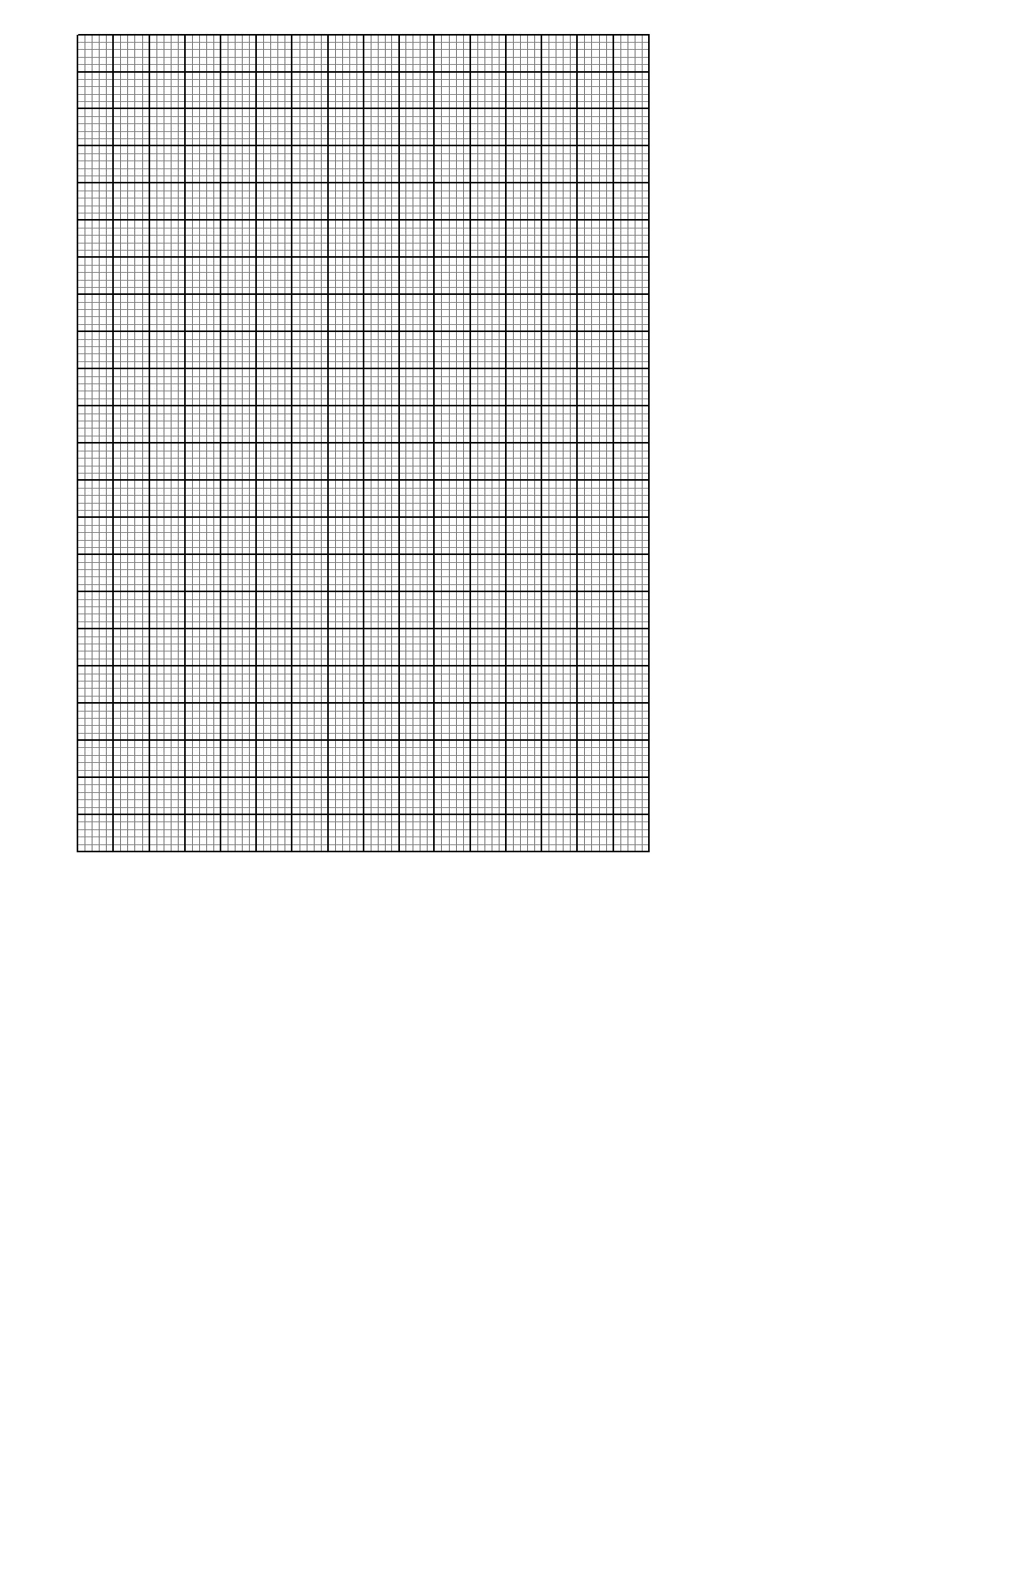

c) Use your graph to solve (3mks)

i. Sin 450

ii sin 130o

iii.The value of x for which – cos x = - 0.26

19.In the figure below, O is the centre of the circle. A, B, C and D are points on the circumference of the circle. A, O, X and C are points on a straight line. DE is a tangent to the circle at D. Angle BOC= 480 and angle CAD = 360.

**E**

**D**

**C**

**B**

**O**

**A**

**36o**

**48o**

**X**

a.Giving reasons or otherwise, find the value of the following angles:-

1. Angle CBA (1mk)
2. Angle BDE (2mks)
3. Angle CED (3mks)
4. It is also given that AX = 12 cm, XC = 4 cm, DB = 14 cm and DE = 20 cm.

Calculate:

1. DX (2mks)
2. AE (2mks)

20.a) Using a ruler and compasses only, construct triangle ABC such that AB=4cm, BC=5cm and ∠ABC = 1200. Measure AC. (4mks)

b) On the diagram, construct a circle which passes through the vertices of the triangle ABC. Measure the radius of the table. (4mks)

c) Construct a perpendicular from the centre of the circle to the line BC. Measure the length of the perpendicular. (2mks)

21. A metal sphere has a radius 5cm and a density of 2.4g/cm³.

a. Calculate the mass of the ball in kg (4mks)

b.The ball is dropped into a cylindrical container which is partially filled with water.

The ball is fully sub-merged. If the cylinder has a base radius of 8cm, calculate the

change in the water level. (3mks)

c. The sphere is melted down to form a metal cylinder of same radius. Calculate the height of the cylinder formed.

(3mks)

22.In the triangle OPQ below, **OP** = **p** and **OQ** = **q**. R is a point on PQ such that PR: RQ = 1 : 3 and 5OS = 2 OQ. PS intersects OR at T.

T

**q**

S

Q

R

P

O

**p**

( a ) Express in term of **p** and **q**

1. **OS** (1mark)
2. **PQ** (1mark)
3. **OR** (2mark)

( b )Given that **OT**= h**OR** and **PT** = k**PS**. Determine the values of h and (6marks)

23.(a) Given that the matrix A= Find A-1 the inverse of A= $\left[\begin{matrix}2 & 3 \\ 3 & 4\end{matrix}\right]$ (2mks)

(b) Kimtai bought 200 bags of sugar and 300 bags of rice for a total of Kshs. 850,000. Buya bought 90 bags of sugar and 120 bags of rice for a total of Kshs. 360,000. If the price of a bag of sugar is Kshs **x** and that of rice is Ksh **y**

(i) Form two equations to represent the information above (2mks)

(ii) Use the matrix A-1 to find the prices of one bag of each item. (4mks)

(c)Kali bought 225 bags of sugar and 360 bags of rice. He was given a total discount of Kshs. 33,300.If the discount on the price of a bag of rice was 2%, calculate the percentage discount on the price of a bag of sugar.

(4mks)

24.Mr Rao is a water supplier in a certain market. He has a tank which holds 20,000 litres. The tank is being filled with water from two pipes P and Q. Water flows at the rate of 150L/minute through pipe P and 100l/minute through pipe Q.

1. If the tank is empty and the two pipes are opened at the same time, calculate the time taken to fill the tank. (4 marks)

b.On a certain day Mr Rao started with an empty tank, opened pipes P and Q for 30 minutes, after which he opened pipe R to supply his customers. R supplies water at a rate of 20 litres per minute.

Calculate the time it took to fill the tank. (6marks)