Name__________________________________________________________ Admission No. ____________Class____

Candidate’s signature _____________________________Date _________________________

**121/1**

**MATHEMATICS**

**PAPER 1**

**2 ½ HOURS**

**MECS JOINT EXAMINTIONS 2024**

***TERM THREE*** *- Kenya Certificate of Secondary Education*

**FORM THREE**

**MATHEMATICS**

**PAPER 1**

**Instructions to Candidates**

1. Write your **name, Admission number and class** in the spaces provided.

2. Sign and write date of the examination in the spaces provided.

3. The paper contains **TWO sections**: **Section I and II**

4. Answer **ALL** questions in section I and **STRICTLY ANY FIVE** questions from section II.

5. All working and answers must be written on the question paper in the spaces provided below each question.

6. Show all the steps in your calculations, giving your answers at each stage in the spaces below each question.

7. Marks may be awarded for correct working even if the answer is wrong.

8. This paper consists **16 printed pages.** The candidates should check to ascertain that all the pages are

printed as indicated and no question is missing.

9. **Non-programmable** silent electronic calculators and **KNEC** Mathematical tables may be used except where stated otherwise.

**For Examiner’s use only**

**Section I**

|  |  |  |  |  |  |  |  |  |  |  |  |  |  |  |  |  |
| --- | --- | --- | --- | --- | --- | --- | --- | --- | --- | --- | --- | --- | --- | --- | --- | --- |
| 1 | 2 | 3 | 4 | 5 | 6 | 7 | 8 | 9 | 10 | 11 | 12 | 13 | 14 | 15 | 16 | TOTAL |
|  |  |  |  |  |  |  |  |  |  |  |  |  |  |  |  |  |

**GRAND TOTAL**

**Section II**

|  |  |  |  |  |  |  |  |  |
| --- | --- | --- | --- | --- | --- | --- | --- | --- |
| 17 | 18 | 19 | 20 | 21 | 22 | 23 | 24 | TOTAL |
|  |  |  |  |  |  |  |  |  |

**SECTION 1(5O MARKS)**

***Answer all questions in the section***

1. Without using tables or calculators evaluate (3marks)

$$\frac{\sqrt{5184}}{5\frac{5}{8}×1\frac{7}{9}-\frac{5}{4}of4\frac{4}{5}+2\frac{4}{5}÷\frac{7}{10}}$$

1. Given that the ratio $m:n=3:4$, find $\left(3m+2n\right):(4n-m)$ (2marks)
2. A man walks directly from point **A** towards the foot of a tall building 240m away. After covering 180m, he observes that the angles of elevation of the top of the building is **450**. Determine to 1 decimal place, the angle of elevation of the top of the building from **A**.

(4marks)

1. Solve for $x$ in the equation (3marks)

$\frac{x-2}{5}-\frac{2x-2}{6}=\frac{1-x}{3}$

1. If $a=\left(\begin{matrix}1 \\ y-1\end{matrix}\right), b=\left(\begin{matrix}3 \\ y+2\end{matrix}\right)$ and $\left|a\right|=\left|b\right|$, find the value of y. (3 marks)
2. 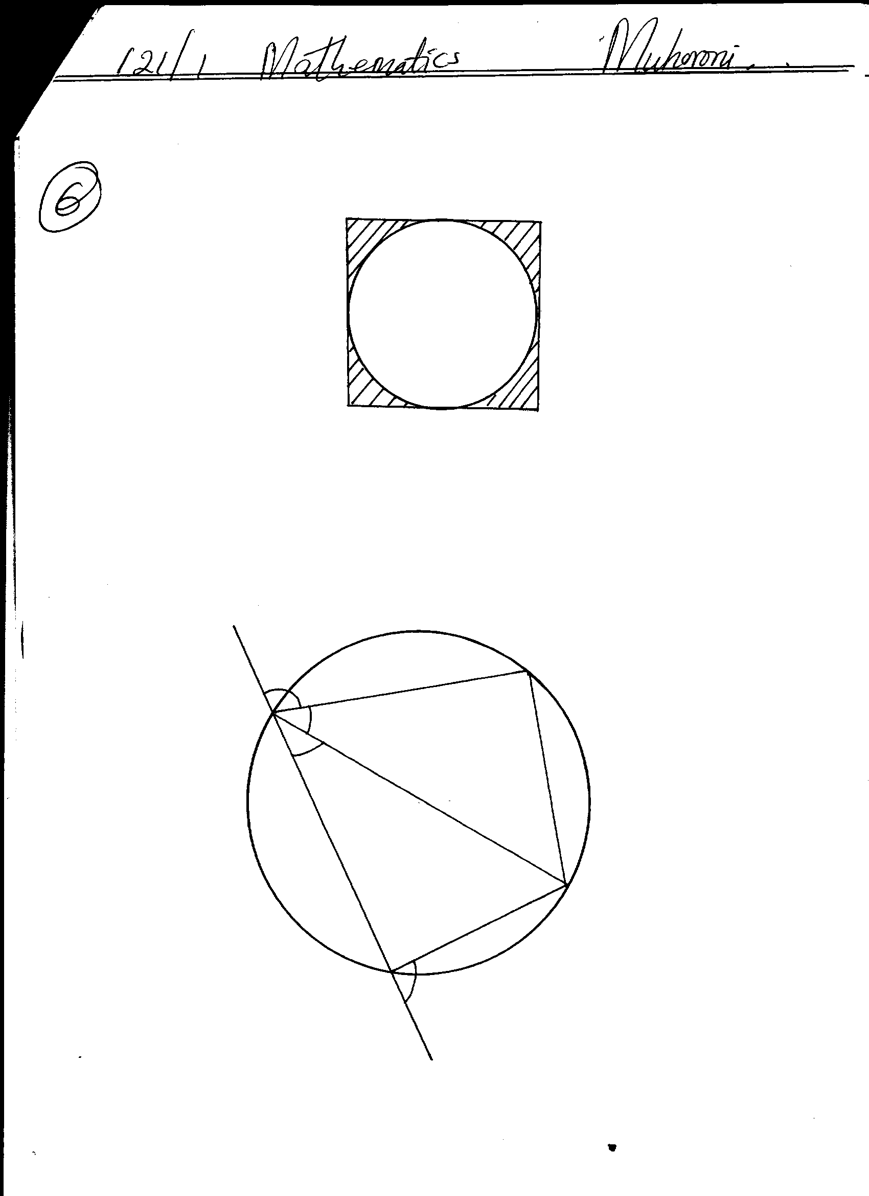A circle is inscribed in a square as shown below.

What percentage of the square is not covered by the circle? Give your answer correct to

2 decimal places (use π $=\frac{22}{7}$) (3marks)

1. A Kenyan bank buys and sells foreign currencies as shown below:

|  |  |  |
| --- | --- | --- |
| Currency | Buying (Ksh.) | Selling(Ksh.) |
| US dollar | 127.65 | 128.13 |
| Hong Kong Dollar | 59.68 | 59.85 |

A tourist from USA arrived in Kenya with 15,785 US dollars and changed the whole amount to Kenya Shillings. While in Kenya, he spent Ksh. 1,337,528 and changed the balance to Hong Kong dollars before leaving for Hong Kong. Calculate the amount, in Hong Kong dollars, that he received. (3marks)

1. A watch which loses a half-minute every hour was set to read the correct time at 0545h on Monday. Determine the time, in the 12 hour system, the watch will show on the following Friday at 1945h. (3 marks)
2. Simplify the expression (3marks)
$$\frac{4t^{2}-25a^{2}}{6t^{2}+9at-15a^{2}}$$

3. Using a ruler and a pair compasses only to construct trapezium **ABCD** in which **AB** is parallel to **DC**, **AB = 8cm**, angle **BAD**= ${67.5}^{0}$, **AD=5cm, BC**=**5.5cm** and angle ABC is acute. (3marks)

1. The exterior angle of a regular polygon is equal to one-third of the interior angle. Calculate the number of sides of the polygon and give its name. (4marks)
2. Use logarithms to evaluate (4 marks)

$$\sqrt[3]{\frac{45.3 × 0.00697}{0.534}}$$

1. Simplify $\frac{{25}^{\frac{3}{4}}×{0.9}^{2}×2^{2}}{5^{\frac{3}{2}}×3^{3}}$ in the form $\frac{A}{B}$ where **A** and **B** are integers. (3marks)

1. Given that $sin (x + 30)^{0} = Cos 2x^{0}.$

Find the value of ***x***  (2marks)

1. Solve for ***x***  in $2 3 - x 5$*,*hence state the integral values (3marks)
2. The diagram below represents a right rectangular based pyramid of 5 cm by 4 cm. The slant edge of the pyramid is 6 cm. Draw and label the net of the pyramid. **(3 marks)**

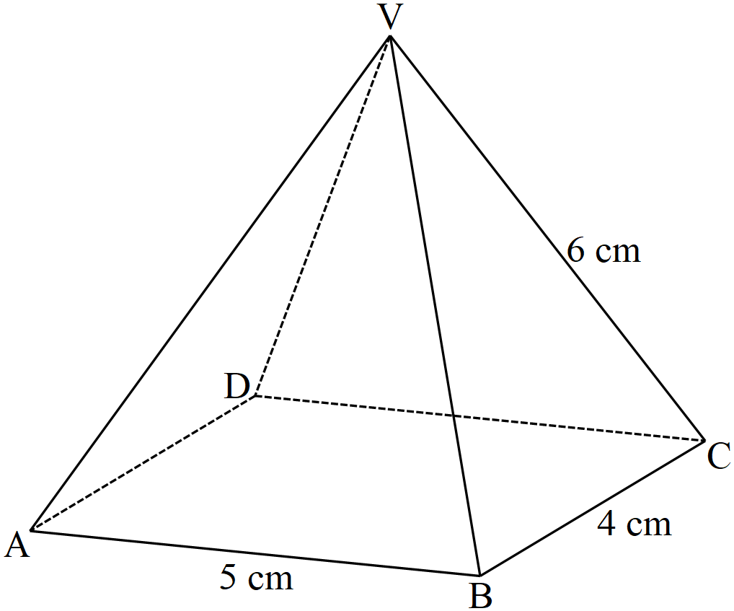

**SECTION II (50MARKS)**

**Answer only FIVE questions from this section**

1. A town hall has 200 seats. During the county Drama Festival, tickets were sold at sh 150 for adults and sh 75 for students.

(a) On day one of the festival 80% of the seats in the hall were occupied and twenty of the seats were occupied by students. Calculate the total money collected from the sale of tickets this day. (3marks)

(b) On the last day of the festival,***x*** students occupied the seats and all seats were occupied. The money collected from the tickets sales was sh 25,350. Write down an equation of ***x****,* hence find the value of x. (3marks)

(c) The money collected from the sale of tickets during the festival was divided among cost of hosting, allowances for adjudicators and electricity bill in the ration 7: 3: 2. If the allowances amounted to sh 126,000, calculate the

(i) Amount collected during the festival. (2marks)

(ii) The cost of electricity bill during the festival. (2marks)

1. The frequency table below shows the marks scored by the 40 pupils in a mathematics test.

|  |  |  |  |  |  |  |  |
| --- | --- | --- | --- | --- | --- | --- | --- |
| Marks | 30 - 39 | 40 - 49 | 50 - 59 | 60 - 69 | 70 - 79 | 80 - 89 | 90 - 99 |
| Number of pupils | 2 | 3 | 10 | 12 | 8 | 3 | 2 |

(a) State the modal frequency. (1mark)

(b) Calculate the mean mark. (5marks)

(c) Calculate the median mark. (4marks)

1. (a) Triangle **PQR** has vertices at **P**(3,-1), **Q**(5, 2) and **R**(2, 3). Plot and draw **P׳QR׳** on the grid provided. (1mark)



(b)Given that triangle **P׳ Q׳ R׳** is the image of **PQR** under positive quarter turn about the origin, plot and draw P׳Q׳R׳ on the same axes as PQR (3marks)

(c) **P″Q″R″**is the image of **P׳Q׳R׳** after reflection in the line y+x =0. Plot and draw **P″Q″R″** on the

same axes as **PQR** and **P׳Q׳R׳** above. (3marks)

(d) State the pairs of triangles above that are:

(i) oppositely congruent (2marks)

(ii) directly congruent (1mark)

1. Given that a line  passes through the points  and ,

(a) find the equation of line in the form   **(2 marks)**

(b) find the equation of a line , which is perpendicular bisector of line . Leave your answer in the form , where a, b and c are integers. **(3 marks)**

(c) Given that another line  is parallel to  and passes through point  find the

equation of line **(2 marks)**

(d) The coordinates of the point of intersection of lines and  **(3 marks)**

1. During a surveying exercise to establish a housing estate a surveyor marked out four points W,X,Y and Z to represent an area to be left out for a shopping complex and social amenities. Point X is 240m on a bearing of 0730 from point W. Point Y lies on a bearing of 1450 at a distance of 300m from X. Z is directly south of W a distance of 320m.
2. Draw a scale diagram to represent the relative positions of the area under survey

**Scale 1cm represents 40m. (4 marks)**

1. Using the scale diagram in (a) above, determine
2. The distance and bearing of point Z from Y **(2 marks)**
3. The bearing of point X from point Z. **(1 mark)**
4. A road is to be constructed directly South of X to meet another road from Y westwards at point P. Find the area enclosed by triangle PXY in hectares. **(3 marks)**
5. A bus left Nairobi at **8.00 am** and travelled to Kisii at an average speed of **80km/h**. A car left Kisii at **8.30 am** and travelled to Nairobi at an average speed of **120km/h**. Given that the distance between Nairobi and Kisii is **400km**, calculate,

(a) The time the car arrived in Nairobi. (3 marks)

(b) the time it took for the two vehicles meet. (3 marks)

(c) The distance from Nairobi to the meeting point. (2 marks)

(d) The distance of the bus from Kisii when the car arrived in Nairobi. (3 marks)

1. A paper cup is made in the shape of a frustum of a cone with an open top of diameter 10.5cm and a sealed bottom of diameter 7cm. it has a depth of 12cm, calculate using π= $\frac{22}{7}$:
2. The total surface area of the cup. (6 marks)
3. The capacity of the cup to the nearest litres. (4 marks)
4. A certain number of people agreed to contribute to buy novels worth sh. 1200. Five of them pulled out and the others agreed to contribute an extra Sh. 10 each. Their contribution brought novels worth sh.200 more than they originally expected.
   1. If the original number of people was x, write an expression of how much each was

to contribute. (1mark)

* 1. Write down two expressions on how much each contributed after the five pulled

out and reduced them to a single equation. (2marks)

* 1. Calculate how many people made the contribution (5marks)
  2. How much did each contribute? (2marks)