**JULY/AUGUST MOCK 2024**

*Kenya Certificate of Secondary Education (K.C.S.E.)*

NAME……………………….…………………………………….ADMNO………….

STREAM…………………............................NAME OF SCHOOL...............................

DATE………………………………..…..SIGN…………………………….………….

**FORM FOUR EXAMINATIONS**

BIOLOGY THEORY

231/1

TIME: 2HRS

**INSTRUCTIONS**

* All Questions are Compulsory
* Write your Answers in the Spaces Provided
* Wrong Spelling of Technical Terms shall be Penalized

|  |  |
| --- | --- |
| Max Score | Student’s Score |
| 80 |  |

1. a) State the main importance of a lens in a light microscope (1mk

………………………………………………………………………………………………………………………………………………………………………………………………

b) Why is the electron microscope said to be safer to the eyes than light microscope?

……………………………………………………………………………………………………………………………………………………………………………….………..(1mk

1. The diagram shown below represents a common organelle

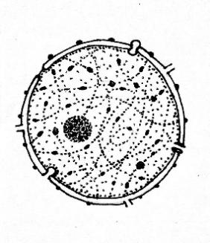

**X**

**Y**

a) Name a Kingdom that: (2mks

1. Has structure **X** …………………………………………………………………….
2. Lacks Structure **X** ………………………………………………………………….

b) How is structure **Y** important in growth and development of organisms? (2mks

………………………………………………………………………………………………………………………………………………………………………………………………

1. Use the diagrams of nerve cells shown below to answer the questions that follow

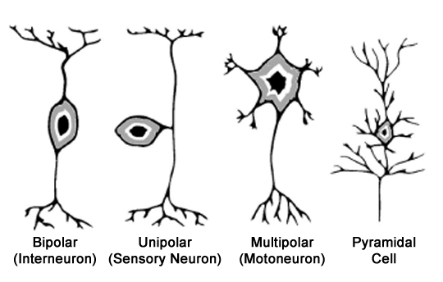

**R**

**Q**

**P**

1. Which letter represents a nerve cell that: (2mks

i) Has its cell body outside the grey matter of CNS …………………………………...

ii) Transmits impulse to effector muscles ………………………………………….......

1. Arrange the letters in sequence to show a reflex arc .........................…………….(1mk

…………………………………………………………………………………………

1. The following is a graph representing results of an investigation on a physiological process when potato strips were placed in different sucrose solutions.

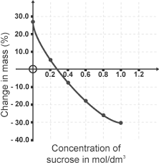

**M**

1. Explain why the concentration at **M** is the normal cell sap concentration of potato cells used in the experiment (2mks

………………………………………………………………………………………………………………………………………………………………………………………………

1. Why is there no further change in weight at 1.0mol/dm3 sucrose concentration? (1mk

………………………………………………………………………………………………………………………………………………………………………………………………

1. Give **TWO** conditions necessary for osmosis to take place (2mks

………………………………………………………………………………………………………………………………………………………………………………………………………………………………………………………………………………………………

1. State **THREE** evolutionary features that make human beings to be more developed than the other living organisms (3mks

………………………………………………………………………………………………………………………………………………………………………………………………………………………………………………………………………………………………………………………………………………………………………………………………

1. A dwarf garden pea plant was crossed with a tall garden pea plant and all the off springs were tall.
2. Why was there no dwarf offspring? (1mrk

………………………………………………………………………………………………………………………………………………………………………………………………

1. Write the genotype of the off-springs using letter d for the gene for dwarfness (1mrk

………………………………………………………………………………………………………………………………………………………………………………………………

1. a) Name the part of chloroplast where light-independent reactions take place 1mk

………………………………………………………………………………………………………………………………………………………………………………………………

b) State the importance of light-dependent photosynthetic reactions to:

i) Animals (1mk

………………………………………………………………………………………………………………………………………………………………………………………………

ii) light-independent photosynthesis phase (2mks

………………………………………………………………………………………………………………………………………………………………………………………………………………………………………………………………………………………………

1. Samwel observed the image of an onion epidermal cell with a diameter of 300micrometers under a light microscope using X15 eye piece lens and X40 objective lens. Determine the actual diameter of the onion cell (3mks

………………………………………………………………………………………………………………………………………………………………………………………………………………………………………………………………………………………………………………………………………………………………………………………………………………………………………………………………………………………………………………………………………………………………………………………………

1. The following is a process that takes place in some cells and unicellular organisms

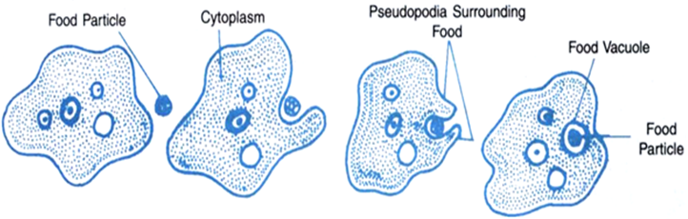

1. Identify the process shown above (1mk

………………………………………………………………………………………………

1. Which human white blood cell is capable of the activity named in a) above? (1mk

………………………………………………………………………………………………

1. Which other way does the white blood cell fight pathogens in addition to the method shown above? (1mk

………………………………………………………………………………………………………………………………………………………………………………………………

1. Name the micro-organisms that cause the following diseases (2mks
2. Bilharzia

………………………………………………………………………………………………………………………………………………………………………………………………

1. Amoebic dysentery

………………………………………………………………………………………………………………………………………………………………………………………………

1. Give differences of the endoplasmic reticula in terms of the following features (2mks

|  |  |  |
| --- | --- | --- |
| **Feature** | **Smooth Endoplasmic Reticulum** | **Rough Endoplasmic Reticulum** |
| Structure |  |  |
| Function |  |  |

1. The following is an illustration of a flower

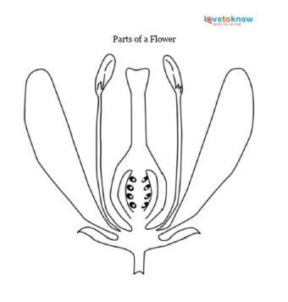

**Q**

1. State **TWO** ways part **Q** helps encourage pollination by insects (2mks

………………………………………………………………………………………………………………………………………………………………………………………………………………………………………………………………………………………………

1. Give **TWO** features which promote self-pollination in the flower shown above (2mks

………………………………………………………………………………………………………………………………………………………………………………………………………………………………………………………………………………………………

1. The following is a simplified Nitrogen Cycle

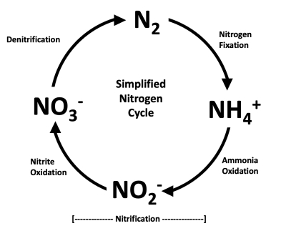

1. Explain why denitrification is disadvantageous to plants (1mk

………………………………………………………………………………………………………………………………………………………………………………………………

1. Name the bacteria found at the following stages of the cycle (2mks

i) Nitrogen fixation ………………………………………………………………………...

ii) Nitrification ……………………………………………………………………………..

1. a) Name an enzyme that is important in the transport function of red blood cell (1mk

………………………………………………………………………………………………………………………………………………………………………………………………

b) Give **TWO** adaptations of the red blood cell that arise from its external appearance

………………………………………………………………………………………………………………………………………………………………………………………………………………………………………………………………………………………..(2mks

1. The following is an organ obtained from a freshwater fish

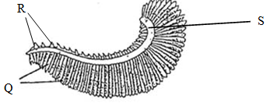

1. State the function of the organ (1mk

………………………………………………………………………………………………………………………………………………………………………………………………

1. Name the parts labelled **Q** (1mk

………………………………………………………………………………………………

1. State the importance of parts **R** and **S** to function of part labelled **Q** (2mks

i) **R**

………………………………………………………………………………………………………………………………………………………………………………………………

ii) **S**

………………………………………………………………………………………………………………………………………………………………………………………………

1. Differentiate between homozygote and heterozygote cells (2mrks

………………………………………………………………………………………………………………………………………………………………………………………………………………………………………………………………………………………………

1. Use the following images of living organisms to answer the questions that follow

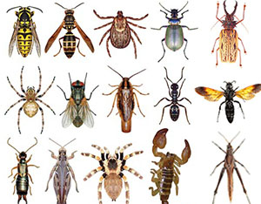  

**V W X**

1. Why is it that Organism **V** belongs to Class Arachnida? (1mk

………………………………………………………………………………………………………………………………………………………………………………………………

1. Develop a two-stage dichotomous key to identify the organisms above using the following features: (4mks
   * + 1. Wings
       2. Antennae

………………………………………………………………………………………………………………………………………………………………………………………………………………………………………………………………………………………………………………………………………………………………………………………………

1. a) State **TWO** ways change in body color of a chameleon is important for its survival

……………………………………………………………………………………………………………………………………………………………………………………………………………………………………………………………………………………….(2mks

b) State **TWO** conditions necessary for competition to exist in an ecosystem (2mks

………………………………………………………………………………………………………………………………………………………………………………………………………………………………………………………………………………………………

1. a) Name the endocrine tissue found in the Pancreas. (1mk

………………………………………………………………………………………………

b) Explain the role of the tissue named in a) when sugar level rises above normal (2mks

……………………………………………………………………………………………… ………………………………………………………………………………………………

1. Wanjiku placed little maize flour in a boiling tube and heat it for 6 minutes as shown below

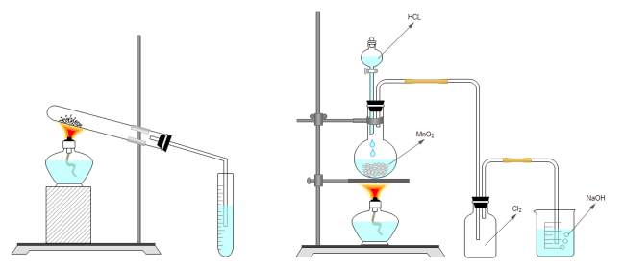

**Lime Water**

**Maize Flour**

1. What was the aim of the experiment? (1mk

………………………………………………………………………………………………………………………………………………………………………………………………

1. State the expected observation in the lime water (1mk

………………………………………………………………………………………………………………………………………………………………………………………………

1. Explain the importance of the human body to continuously expel the investigated gas?

……………………………………………………………………………………………………………………………………………………………………………………..…(2mks

1. a) A 60cm long fish was found to measure 25cm from the head to the anus. Calculate the tail power of the fish (2mks

………………………………………………………………………………………………………………………………………………………………………………………………………………………………………………………………………………………………………………………………………………………………………………………………

b) Periodically, fishermen around rivers do observe migration of fish against the water currents to seek freshwater as their breeding grounds. Name the response exhibited by the fish (1mk

………………………………………………………………………………………………………………………………………………………………………………………………

1. The following illustration represents a section of the thoracic vertebra

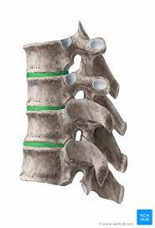

**V**

**W**

**U**

1. Which letter represents a part that articulates with the rib? (1mk

.……………………………………………………………………………………………

1. Give **TWO** functions of part labelled **V** 2m s

……………………………………………………………………………………………… ………………………………………………………………………………………………

1. Use the illustration of the development cycle of an insect below to answer questions that follow

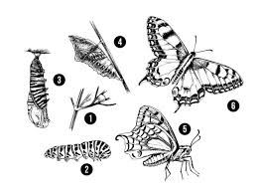

1. Name the hormone responsible for the changes observed above 1mk

…..………………………………………………………………………………………….

1. Give **TWO** Reasons why stages **2** and **5** occupying different niches is important for the survival of the butterfly. (2mks)

………………………………………………………………………………………………………………………………………………………………………………………………………………………………………………………………………………………………

1. In an experiment, Substance **Q** was mixed with iodine solution, and it gave a blue-black color. **Q** was then maintained in a solution containing Enzyme **K** for 15minutes at 370C and formed Substance **J** which when boiled with reagent **Z** gave a brick red color.
2. Give the identity of the following: (2mks
3. Enzyme **K** ………………………………………………………………………………
4. Reagent **Z** ………………………………………………………………………………
5. i)State **ONE** property of **J** (1mk)

………………………………………………………………………………………… ………………………………………………………………………………………………

ii) Why was the temperature maintained at 370C ? (1mk)

……………………………………………………………………………………………… ………………………………………………………………………………………………

1. Account for the color to be observed when Substance **Q** is reacted with Enzyme **K** in the presence of dilute Hydrochloric acid and Reagent **Z** added?

……………………………………………………………………………………………… ……………………………………………………………………………………………… ……………………………………………………………………………………..…(2mks

END